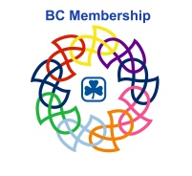

TMBR Here’s What’s Next
Challenge Completion Form

Name:
iMIS Number :
Mailing Address:

Element | Description | Date Completed | Comments
Safe Guide training
Other training
Unit Participation
Councils and committees
Other (not required)

What was your favorite part of the challenge?

What would you change about the challenge?

How do you intend to stay connected to Guiding as a young adult? Please circle all that apply.

Join a unit as a leader |  | Committee or council position |  | Link |  | I don’t plan to stay

I certify I have completed all elements of the Here’s What’s Next challenge.
Signature or iMIS number:

Forwarded completed form to Membership@bc-girlguides.org.
Your pin and certificate will be mailed directly to the address on this form

