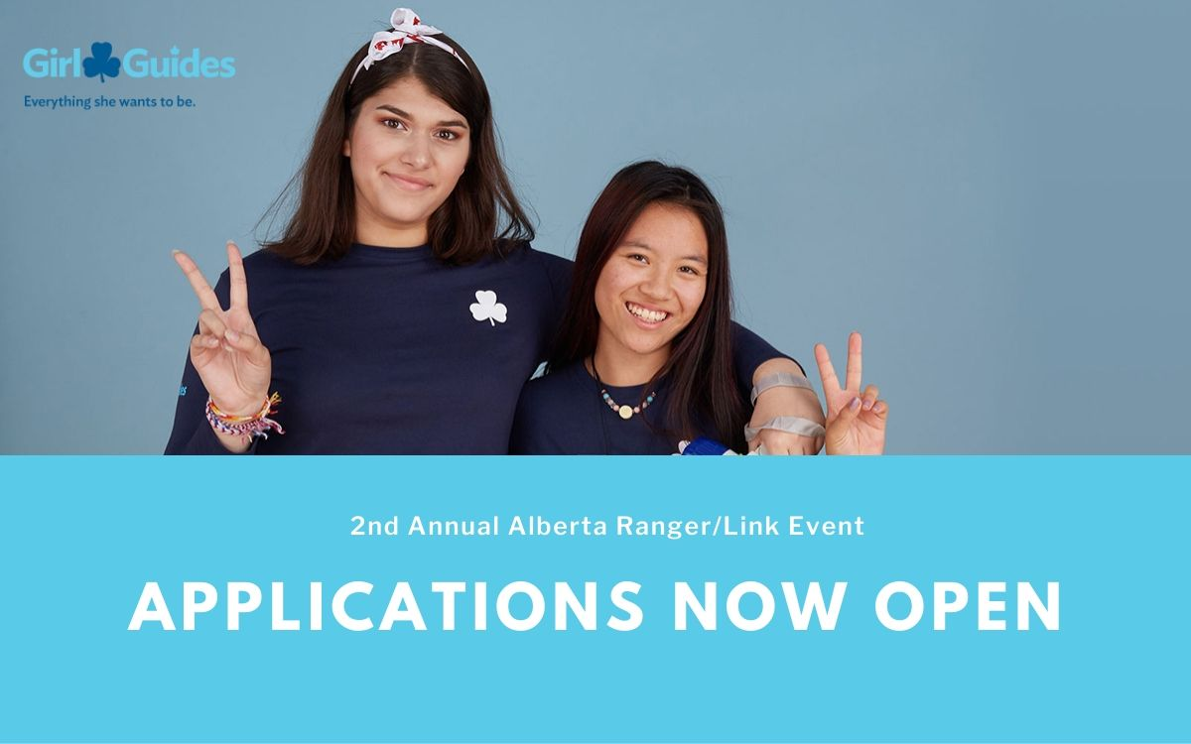

Application for Provincially Funded Trip to the 2nd Annual Alberta Ranger/Link Event NOW OPEN!

Application Deadline: February 21st 2020
Interested in adding some Guiding experience to your resume? Travel to Alberta on a Provincially funded trip to participate in the 2nd Annual Alberta Ranger/Link event as the representative from Nova Scotia!

Who: ONE Ranger Member and ONE Link Member (Youth age 18-30)
Where: Tangletrees Girl Guide Camp, Mulhurst Bay, AB
When: May 8th - May 10th 2020
Why: Join Ranger and Link members from across Canada for a weekend of fun and friendship! This weekend long event will give youth the opportunity to learn new skills that will help you in Guiding and beyond. Make your weekend what you want it to be with your choice of sessions. Program choices could include – astronomy, archery, outdoor cooking, hiking 101, first aid, a service project and many more. Accommodations will be in bunkhouses but camping experience will come in handy. If you love camping, learning, and exploring new places, this is the trip for you!
Cost: Travel, accommodation, meals, and event fees will all be covered by Girl Guides of Nova Scotia for the selected applicant.
Upon Return: You will be required to do a presentation for the Provincial Council to discuss your adventures.
What to submit:
- Completed Application
- Reference Letter
- Resume
Please submit your application to ns-ggc@girlguides.ca by Feb 21st.
The selected applicant will be contacted in March 2020.

