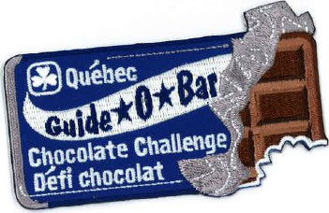
ORDER FORM
Québec Chocolate Challenge Crests

Chocolate has been around a long time. Learn about the history of chocolate and how it first came to North America. Learn about how beans become chocolate. Using a world map, locate where cacao beans are grown. Where is most chocolate processed and consumed? What journey does the cacao bean undergo from picking to ending up as a bar of chocolate?

Crests are $1.75 each. Please complete this form and email it to: qc-crests-ecussons@guidescanada.ca

Guider name: Guider iMIS:

Guider email address:

Unit/District/Area:

Number of crests:

Please mail the crests to: (Let us know if the crests will be picked up at the office.)

Name: (if different from above)

Mailing Address:

Street:

City: Province:

Postal code:

PAYMENT

We will send you an invoice for the total amount including 5% GST, 9.975% QST and shipping costs.
Payment is accepted by cheque or credit card.

Cheques should be made out to: ‘GGC Québec Council’ and sent to: GGC QC Provincial office, 100 boul. Alexis-Nihon, Suite 270, Saint-Laurent, QC, H4M 2N7

If you would like to pay by credit card, please fill out the details below or phone us at 514-933-5839

Payment by Credit Card: | Credit Card Number
Visa Mastercard | Name on card |  |  | Expiry Date | /

