SASKATCHEWAN COUNCIL 2016 ANNUAL REPORT
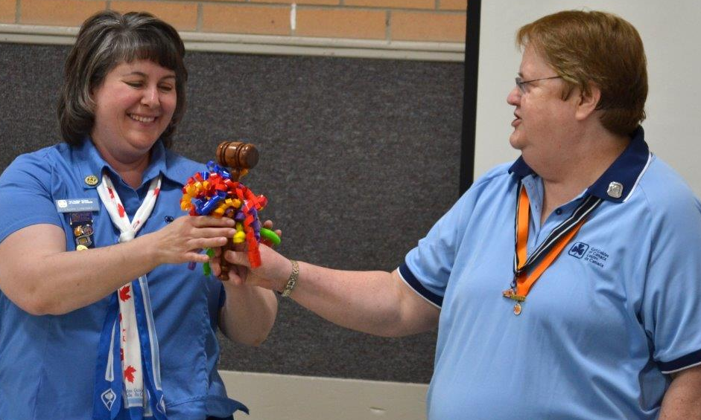
I am pleased to provide you with the 2016 Girl Guides of Canada – Guides du Canada – Saskatchewan Council Annual Report. The Annual report is an opportunity to highlight the successes of the year and offer thanks to those who have supported the organization.
Girl Guides in Saskatchewan offers relevant and dynamic programs and activities that help our members realize their full potential while having fun and developing friendships. The mission of Girl Guides of Canada-Guides du Canada is to enable girls to be confident, resourceful and courageous, and to make a difference in the world. Guiding in Saskatchewan continues to be a vibrant organization. We ensure that our members develop the skills to thrive and make a difference in their families, communities and in their world.

In 2016, our membership was at 3476 (2680 girl members and 796 adult members).
Girls are the core of the organization. The Saskatchewan GGC Youth Forum has been initiated with a core group of girls ready to bring the voice of the girl to the Provincial Council and to the entire Guiding community in Saskatchewan. Our hope is that the Forum will create an environment for girls to discuss and consult on issues that directly impact them. We hope this supports them to develop initiatives to enhance the program and experiences for the girls in the province. Guiders will be there to assist and help facilitate but ideally, we will allow them to be the drivers of change. This is an exciting opportunity and the Saskatchewan Council looks forward to working with the Youth Forum.

Guiders are the structure and support of the organization. Thank you to the 535 women who volunteer their time as Unit Guiders, District Guiders, and/or hold leadership roles at the District, Area, Provincial or National level. Your dedication and passion for the organization provide opportunities to build self-esteem and leadership skills that empower girls to be who they want to be. Your time is appreciated and valuable.

A special thank you goes to the parents and families that support not only their girl member, but the organization. Thank you for entrusting us with your child (or children). Our adult volunteers strive to provide a program that excites and engages the girls, and it is the encouragement of the families that assist them with this task.

I also would like to take the opportunity to state our appreciation to the Provincial Staff. They bring professionalism, expertise and enthusiasm to their roles ensuring that parents, girls and Guiders have the support and resources available to them.

The Saskatchewan Council would like to acknowledge the financial support provided by the Saskatchewan Parks and Recreation Association (SPRA) and Community Initiatives Fund (CIF). Funds from both agencies help to eliminate cost barriers for girls and Guiders to be active members in the organization. We would also like to acknowledge additional funding provided by Dare Foods to help develop initiatives to establish units in several of the First Nation communities in Saskatchewan. Thank you to all those who support our cookie sales and other fundraising opportunities. All support helps to provide the girls with meaningful resources for unit meetings; to off sets costs of camping experiences; or to enhance travel adventures. Thank you for recognizing the Girl Guides of Canada – Guides du Canada high quality programming and support our initiatives.

I feel honored and humbled to be the Provincial Commissioner for Saskatchewan. I am witness to superb programming for girls, and amazed by the skills and talents of the adult volunteers who champion the impact GGC has in our communities. I do this all with a group of women whom have the same goal. Your Saskatchewan Council and Advisers are dedicated women who work hard to develop resources, provide support and make decisions to enhance the organization. Together we all work together to ensure Saskatchewan Guiding continues to be relevant, vibrant and fun!

Your Very Proud Provincial Commissioner,
Laurie Lanovaz

EFFICIENT AND EFFECTIVE ORGANIZATION
- Overall increase of cookies by 12% (10,800 case Spring; 9,107 cases Fall)
- Trainers provided over 500 hours of training
- Aligned membership assistance sources in to one
application form
- Property upgrades to enhance energy efficiency
- Streamlined the grant funding application process

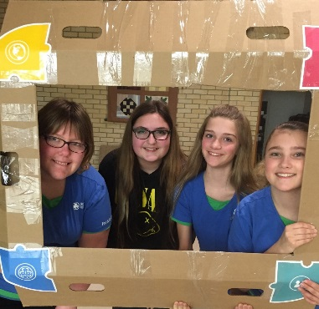
STRONG AND GROWING ORGANIZATION
- 2680 girl members, 796 adult members for a total of 3476 members overall
- Membership increased by 3.27%
- New Units in Buffalo Narrows, Beauval, Carnduff, Green Lake, Shaunavon, Langenburg and Regina
- Increased the number of trainers allowing more training opportunities. 131 Guiders attended January Conference
- Increased our presence on Social Media (Facebook page received nearly 200 new page likes during 2016 – currently sits at 667 likes)
SASKATCHEWAN HONOURARY MEMBERS
Elaine Andreas  Margaret Asquith-Morrey  MaryAnn Assailly  Wendy Barker  June Bleier  Shirley Byrnes  Elaine Chatterson  Marian Clark  Elizabeth Collicott  Margaret Ferguson  Audrey Forrest  Sandra Hamilton | Judith Kehler  May Kletke  Muriel Kochanski  May Lumbis  Eveline Lundgren  Marjorie Martens  Charlene McLean  Patricia Melnychuk  Lois Morrison  Carolyn Oleniuk  Gladys Ollinger  Kathy Palmer | Phyllis Pearson  Rose Ruller  Carol Schimnosky  Carol Skaar  Joyce Spence  Pauline Stenzel  Jo Szostak  Janet Thompson  Bonny Tolley  Gina Troupe  Lorraine Vinterlik  Phyllis White  Sheila Wilson

DYNAMIC PROGRAMMING FOR GIRL GREATNESS
- Day Camps/Sleepovers/ Camping.
- Canoe Skills and Wilderness Training
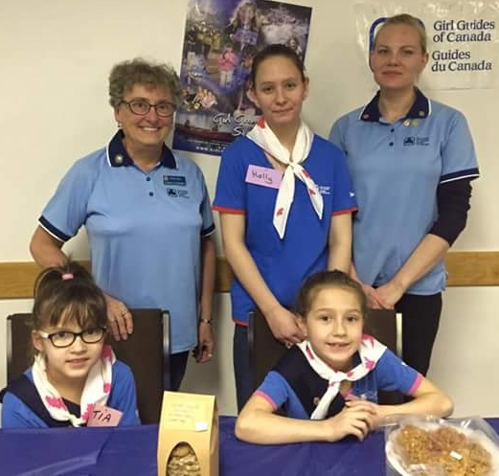
- 472 nights of camping at Can-ta-ka-ye and Heritage
- Lady BP Weekend (25 participants)
- Pathfinder/Ranger Conference (48 participants)
- Sprees/Revels/Rallies/Parties (1725 participants)
- Enhanced Arts
- Community Service
- Environmental Awareness
- Adventure Opportunities
- Public Speaking
- Project Planning
- Shared Leadership Opportunities
- Today’s Life Skills
- Innovative Program Work
- Badge Work
- International Travel
- Interprovincial Travel
- Twinning Challenge – El Salvador
- Hike Around Saskatchewan (500 participants)
CONFIDENCE TO ADVOCATE
- Day of Pink – Anti Bullying
- Words in Action – Literacy Challenge
- Partnered with Read Saskatoon, Frontier College, SK Environmental Society

RESOLUTION OF THANKS
Thank you to the following in appreciation and recognition for support of Saskatchewan Girl Guides
- Saskatchewan Girl Guide Members, Guiders, Girls, Parents, and Families
- Provincial Staff
- GGC National Board & office staff and other Provincial offices
- The Honourable Vaughn Solomon Schofield, Lieutenant Governor of Saskatchewan
- Saskatchewan Parks and Recreation Association
- Saskatchewan Government
- Urban and Rural Communities
- Local Businesses and Service Clubs
- First Nations Bands
- Saskatchewan Media
- EcoFriendly Sask

PROVINCIAL COUNCIL
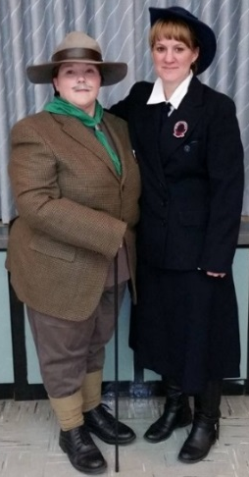
Provincial Commissioner – Laurie Lanovaz
Deputy Provincial Commissioner – Bonnie Jean Low
Deputy Provincial Commissioner – Megan Van Buskirk
Provincial Treasurer - Glenda Eden
Risk and Compliance – Charlotte Courage
Bridging Rivers Area Commissioner – Sara Horseman
Southern Horizons Area Commissioner - Michelle Gibney
Girl Engagement Coordinator – Heather Collier
Member Services Coordinator – Shelley Matsalla
Elected Members: Kay Peters, Alexa Wallace, Desire White

NETWORKS AND ADHOC COMMITTEE CHAIRS
Finance – Glenda Eden  - Cookies – Megan Clake  Risk & Compliance  - Safe Guide – Carol Skaar  Camping – Linette Plant  - Can-ta-ka-ye Operating Chair – Heather Neufeld  - Heritage Operating Chair - Susan Prakash  Communications – Amanda Lang  International – Melissa Gartner | Membership – Charmaine MacDonald  - Awards – Megan Clake  - Link – Emily Bindle  - Trefoil Guild – Judi Kehler  Program – Sara Horseman  - Lones – Lorraine Thibeault  - Special Needs – Vacant  Public Relations – Alice Gaveronski  - Archives – Audrey Forrest  Training – Carrie Morrison  Arts – Janice Graessli
DONATIONS AND GRANTS
The Saskatchewan Girl Guides thank the following: for their generous
and ongoing financial support,
- Saskatchewan Parks and Recreation Association for providing program and membership support
- Community Initiatives Fund for providing program and camp funding
- Saskatchewan Guiders who donated to Sisters to Sisters Fund
- Individual donations from the general public

