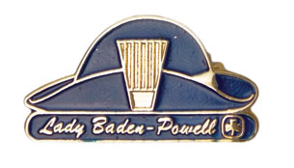**Lady Baden-Powell Weekend**

**March 10 - 12, 2017**

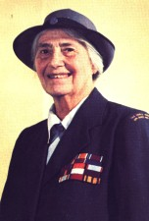This weekend is for third year Guides who are planning to complete their Lady B-P Challenge this year. We will be covering items 2, 3, 4 and 6 of the Lady Baden-Powell Challenge.

**Where**: Yorkton Central School, Yorkton

**When**: Friday, March 10 at 7 pm to Sunday, March 12 at 11 am

**Who:** Third year Guides

**Cost**: $10 plus $.50 GST = $10.50 per girl

**Registration deadline: February 24, 2017** Registration is limited to 50, so register early!

There is no charge for adult supervisors to attain ratio for girls attending. Each Unit sending girls is to provide their own ratio for supervision and provide their own first aider. We will have one first aider on site for the activity, but the medical administration etc will be left to the Unit first aiders. Any Units with three or less girls attending who are unable to provide ratio should contact the Provincial Office at [provincial@girlguides.sk.ca](mailto:provincial@girlguides.sk.ca) . EVENT Safe Guide will be provided, however, Guiders arranging transportation for their units need to follow due Safe Guide protocol and timelines for travel Safe Guide paperwork.

Kit list and any further details will be sent upon receipt of registration form & payment of fee.

*Lady Baden-Powell Weekend Mar 10-12, 2017 Yorkton*

Name: ___________________________________ iMIS#: ________________________________

Phone: ___________________________________ Unit: _________________________________

Circle: girl or adult

Address: __________________________________ Email: ________________________________

Food Allergies and/or Physical Restrictions: ________________________________________________

**Self declaration:**

Optional: For grant purposes please self-identify if you are: 🞏First Nations 🞏Metis 🞏Inuit or 🞏an Immigrant

Payment enclosed: ($10.50 per girl) ___________ (Cheque payable to Girl Guides of Canada, Sask. Council)

OR Credit Card #___________________________________________

(VISA, MC only) Expiry Date: ________________________________

**Please return the completed Registration Form to the Provincial Office:**

Girl Guides of Canada, Saskatchewan Council

200-1530 Broadway Ave, Regina, SK S4P 1E2

OR Email [provincial@girlguides.sk.ca](mailto:provincial@girlguides.sk.ca)

Supported by a grant from Saskatchewan Parks and Recreation Association

OR Fax 306-347-0995

Phone 306-757-4102 Toll Free 1-800-565-8111