MARK YOUR CALENDAR!
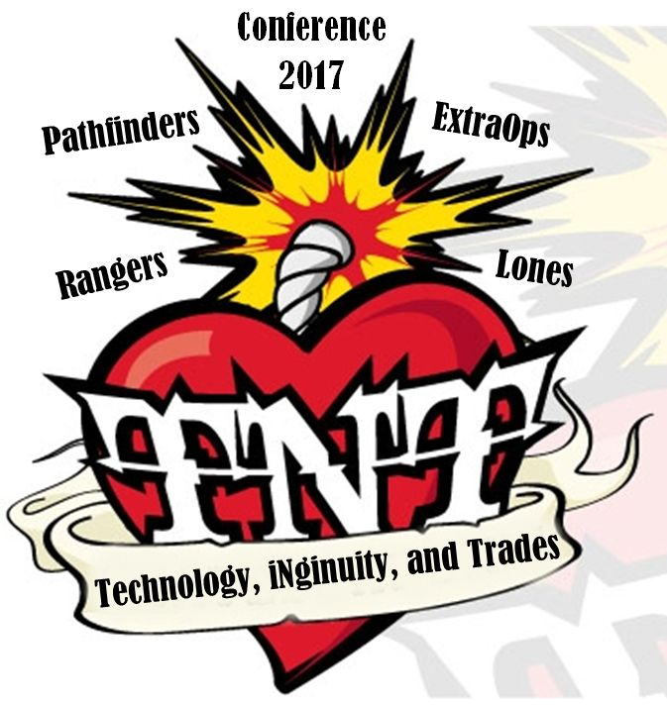
TnT
Technology, iNgenuity, and Trades
Girl Conference `17
March 17-19, 2017
7 p.m. Friday – noon Sunday
Prince Albert, SK
To design or not to design? To paint or not to paint? To film or not to film?
Questions abound as we offer Pathfinders, Rangers, ExtraOps and Lones girls the opportunity to choose sessions at a future-focused conference.

Outside of the session choices, this conference will offer a super star Master Chef inspired dinner, fun rockin’ out fitness choices, a late night coffee house, and MORE!

Cartoon Creation Super Scupltin’ Improv
Painting Party Comp Coding
Watch for registration information in your inbox soon.
Sign up early to secure the best sessions for you!
Supported by a grant from
Saskatchewan Parks and
Recreation Association
Bring your iNgenuity and Guiding friends to the Tech ‘n Trades
girl-focused conference in Prince Albert!

