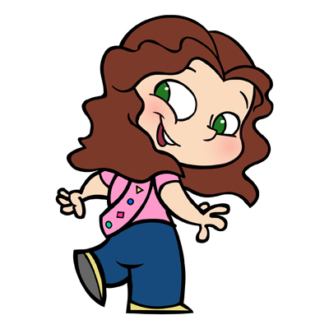Dear Parent or Legal Guardian

When your daughter starts school in September she will be the right age to join a group of 5 and 6 year olds, known as Sparks, the youngest branch of Girls Guides of Canada-Guides du Canada. The Sparks program exposes girls to a wide variety of activities and allows them to begin to explore the world around them in the company of other girls their age.

In Sparks, the emphasis is on developing friendship and learning about community, while also exploring the individual skills and talents of each girl in the unit. Through a varied program that includes activities in the outdoors, the arts and sciences and the community, girls are encouraged to try a bit of everything. No two days in Sparks are alike. Examples of activities at weekly Sparks meetings could include:

- Becoming familiar with the community through excursions to community facilities such as a fire station or a neighbourhood landmark
- Exploring the arts by sculpting animals with playdough or making musical instruments
- Learning about the outdoors on nature scavenger hunts
- Having sleepovers or going camping

Sparks learn to share and to think of themselves as part of a greater community and, along the way, they make friendships that will last a lifetime. Spark units usually meet once a week for one hour but this can vary. Like the other branches of Guiding, Sparks earn special badges to be worn and proudly displayed on their uniform.

To register go to our National website at www.girlguides.ca and click on Join Us. The Unit Finder will help you to find a group near you. If you need a paper application or wish to know more about Sparks, becoming a leader, or another branch of Guiding, please call or e-mail our Provincial Office and we will be pleased to assist you. Membership in our organization is open to adult females and girls over the age of five years. Come join us!

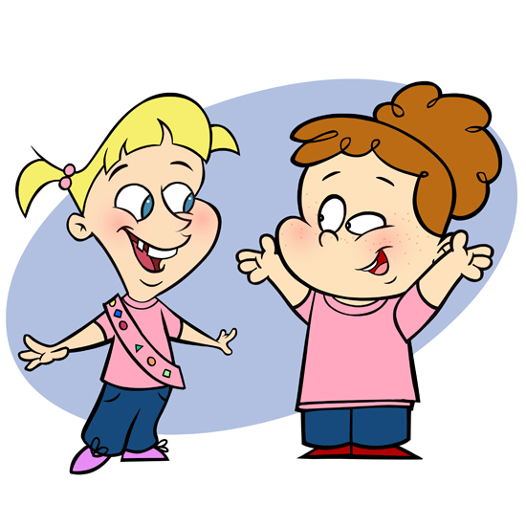Contact: 1-800-565-8111
E-mail: info@bc-girlguides.org
Website: www.bc-girlguides.org

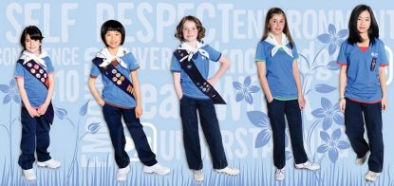Girl Greatness Starts Here

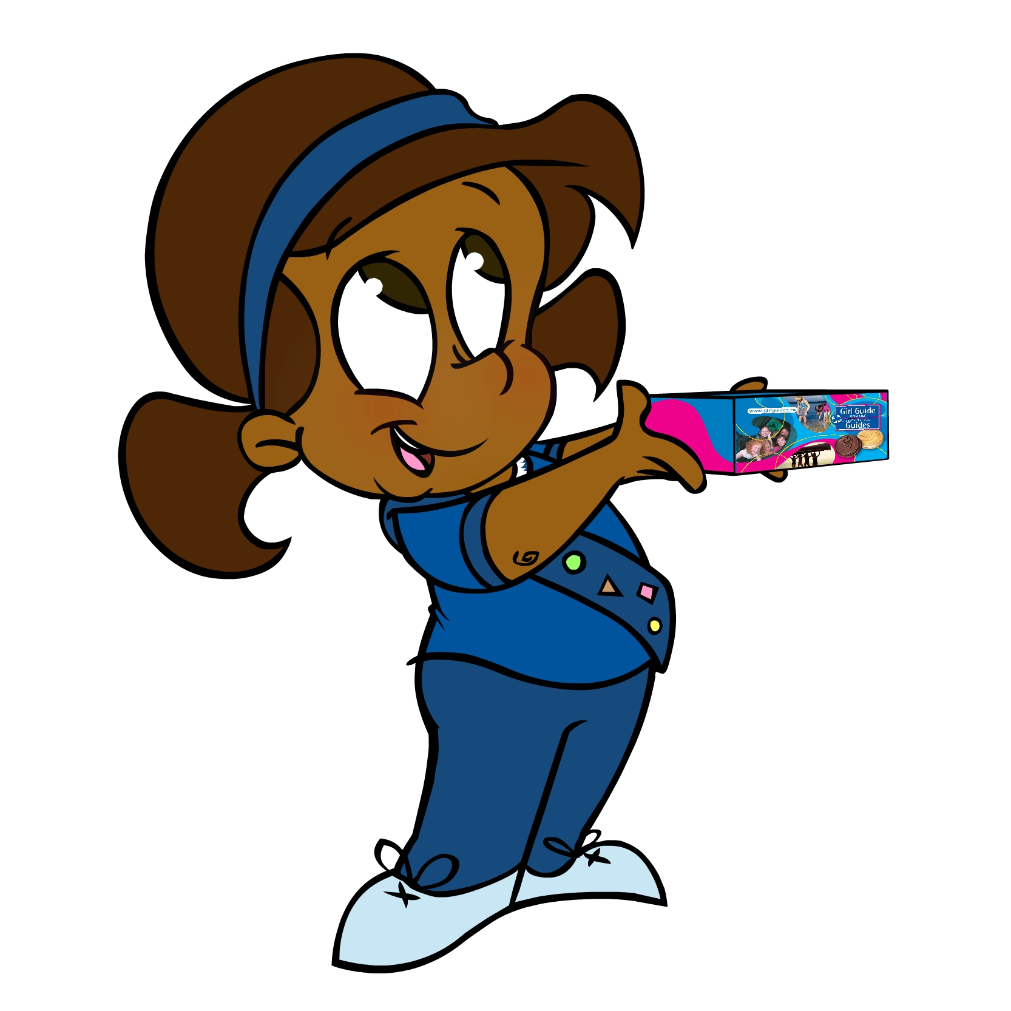
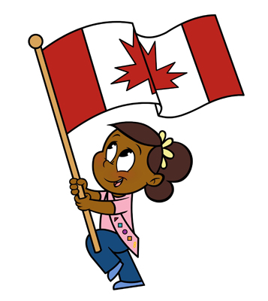
Girl Guides of Canada-Guides du Canada
Information for girls age 5 and 6
Kindergarten age
Sparks
Call 1-800-565-8111
Girl Greatness starts here

