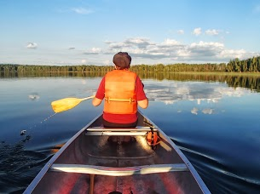
Heritage Lake Ladies Serenity Camp
August 11 – 14, 2017
It's the "Get A Way" That You Deserve!

Free Sessions:

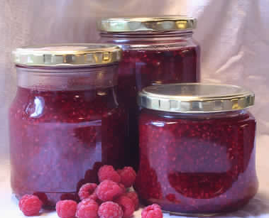
- Yoga on the beach for all ages
- Day hike to Old Trapper's Cabin
- Canoeing, swimming and water sports
- Old fashioned organic jam making class
- Wreaths and Whims craft making class

Paid Sessions:

- Stepping stones inlaid glass $10 for 3 hour session
- Creating natural salves and balms $10
- Reflexology $40 for 50 minutes
- Mini Massages: scalp/back/face $25 for 30 minutes
- Colour Energy soaps, salts and healing accessories $5 - $25.

Please bring cash (no personal cheques) to cover the cost of the “paid” sessions, as banking facilities are not available. Individual session fees will be charged on a cost-recovery basis.
Please note that this is an adult camp focused on rejuvenation, well being
and vitality.

For more information, phone Serenity Camp Director, Susan Prakash at 306-764-7021.

Cost: Guiding Member $130 includes GST
Non-Guiding member $210 includes GST
One Day Fee $ 90 includes GST (includes 3 meals and all free sessions – no overnight)

Registration Deadline: Friday, July 31, 2017

Registrations are processed on a "first come, first serve basis". The registration fee includes all food, accommodations and free sessions. Indoor accommodation in the sleeping lodge is limited, so register early! Outdoor tenting is available.

-----------------------------------------------------------------------------------------------------------------------------------------
Heritage Lake Ladies Serenity Camp 2017 Heritage Lake August 11 - 14, 2017
Name: ____________________________________________________ iMIS #: _______________________

Address: ___________________________________ City/Town: _________________ PC: _______________

Phone: ________________ (h) _____________ (w) Email: ________________________________________

Food allergies and physical restrictions: ________________________________________________________

I prefer to sleep in: _____Bunk (____ top or _____ bottom) _____ Tent _____ Own Tent

My level in swimming is: ______________________________________________
My level in canoeing is: _______________________________________________

Optional: For grant purposes please self-identify if you are: €€ First Nations €€ Metis €€Inuit or €€ € an immigrant.

Fee: ___$130 ___$210 ____ $90 Amount enclosed: _______ (Cheques payable to Girl Guides of Canada, SK Council)
Or ____Visa ____ Mastercard Credit card # ____________________________________ Expiry Date: __________

Return to: Girl Guides of Canada, Saskatchewan Council
200-1530 Broadway Ave., Regina, SK S4P 1E2
Refunds: The fee is refunded less $25 administration fee until two weeks prior to the event. Within those two weeks, a written request must be sent to the provincial office for consideration of any refund.
OR Email: provincial@girlguides.sk.ca (Include all registration information)
OR Phone 306-757-4102 Toll-free 1-800-565-8111
OR Fax: 306-347-0995

