“Heritage 57” Reunion Camp - Sept 2-4, 2017
Saturday, Sept 2 - 2pm check in; join Canada 150 challenges
Sunday, Sept 3 - 10 am Pancake Breakfast
Memories display & sharing
5 pm Weiner Roast
7 pm Campfire
Monday, Sept 4 - 10 am Potluck Brunch; 1pm Check-out
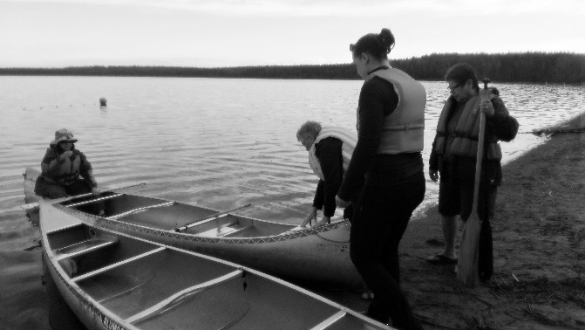
----------------------------------------------------------------------------------
“Heritage 57” Reunion Camp - Sept 2-4, 2017 - Registration
Name: ____________________________________
Address: __________________________________
Contact: # ______________________ email: ___________________________
Number of campers: _______ $57 per adult; $15 per child under 12
Accommodation plan: Tent Sleeping Lodge Trailer
Heritage camping experience: ________________________________________
Total fee payment: _______ Registration and Payment Deadline: August 1, 2017
Send cheque to Provincial office 200-1530 Broadway Ave., Regina, SK. S4P 1E2

