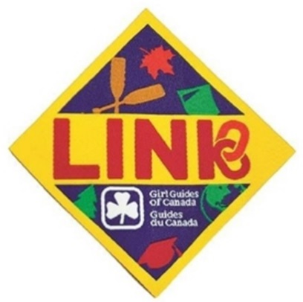
Photo Scavenger Hunt
September 23, 2017 at the University of Saskatchewan
For all adult members and girls turning 18 by December 31st 2017
Registration deadline: Sept. 15, 2017
Saskatchewan Link is hosting a free photo scavenger hunt July 15, open to all SK adult members and youth members turning 18 prior to December 31, 2017. This fun afternoon event will be held on the University of Saskatchewan campus. This is a time to link up with other members of all ages, work on a team to complete each task and have fun. We will meet in Place Riel at 1pm; once all teams are ready the race will begin. For those traveling or who wish to continue the fun, there will be a sleepover at Guide House (801 Preston Ave, Saskatoon). $10 Cost includes your night stay, pizza supper and breakfast.
Name: __________________________________________ IMIS # ________________________
Address: ___________________________ City/Town: _________________ PC: _____________
Phone: _____________________________ Email: _____________________________________
Food Allergies and Physical Restrictions: _____________________________________________
For girls who are turning 18 by December 2017 attending:
Current Unit: ____________ No Unit: ____________ Date of Birth: ______________ Age: ____
Parents Signature: __________________________ Parents Email: _______________________
Phone (Daytime): ________________ (Evening)_________________ (Cell) ________________
Please check all that apply
I am attending the scavenger hunt (free) I am attending the sleepover ($10)
I would like to purchase a Link crest for $2.00.
If you are sleeping over, please check up to 2 pizza Options

____ Cheese
____ Pepperoni
____ Hawaiian
____ Vegetarian
____ All Dressed
____ Meat Lovers

____ I will bring my own food
PLEASE NOTE: A minimum of 10 people required for sleepover at Guide House.
(cheque payable to Girl Guides of Canada, SK Council) or Credit Card # ____________________
(VISA, MC only) Expiry _____/_____

Please return a complete registration form to the Provincial Office
Girl Guides of Canada, Saskatchewan Council
200 – 1530 Broadway Ave. Regina, SK S4P 1E2 OR Phone: 306-757-4102 Toll-free 1-800-565-8111
OR Email: provincial@girlguides.sk.ca (include all registration information)
OR Fax: 306-347-0995

