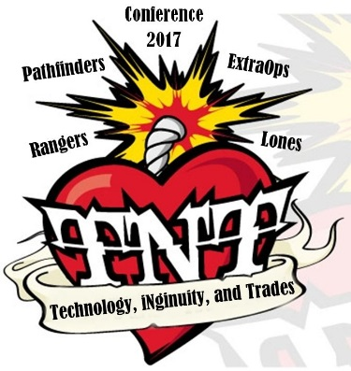

Technology, iNgenuity and Trades

March 17-19, 2017

Pathfinders, Rangers, and Extra Ops

**Register Now! Only 40 youth spaces available!**

**Where:** Vincent Massey Public School Prince Albert

**Cost:** $25 plus 1.25 GST= $26.25 per girl.

**Guiders bringing girls can attend at no charge but are required to register and must complete SG for travel as per usual. Event SG, H1 & kit list will be provided once registered— Deadline 5 pm Friday March 3, 2017.**

Name: IMIS number:

Phone: Unit:

Address: Email:

**Food/Allergies/Dietary/Physical Restrictions**:

Note: there is a 1.2 km walk between venues.

For out of town guests, would you like a “lunch to go” on Sunday? Yes no

Please make session choices (descriptions on next page) with 1 being first choice, 2, second choice, 3 third choice. Be sure to register early to get your first choice as sessions have limited spaces!

1. ____Pound workout _____ Belly Dancing ____ Yoga

2. _____ Wonder Animations _____ Book binding a journal/sketch book ___ Music jam session

3. ______ Wonder Animations _______ Computer coding ______ Painting class

4. ______ Social memes _________ Improv ________ Service project

**Other activities include:**

**Shark Tank Master Chef Competition Coffee House**

Questions? Email culee@sasktel.net

Registration & Fee to provincial@girlguides.sk.ca or call 1-800-565-8111

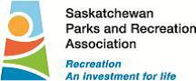

**Bring your iNgenuity and guiding friends to**

**the tech ‘n trades girl focused conference in Prince Albert!**

**Fitness Options:**

**Pound Workout-**POUND® - A rockout workout with Ripstix and Raylene Melnyk.

POUND® IS THE WORLD'S FIRST CARDIO JAM SESSION INSPIRED BY THE INFECTIOUS, ENERGIZING AND SWEAT-DRIPPING FUN OF PLAYING THE DRUMS. Co-creators Kirsten Potenza and Cristina Peerenboom were both recreational drummers and former athletes. They relied heavily on stability-based exercises like Pilates to keep their bodies aligned, symmetrical and lean, but were bored with routine and longed to reignite the fun in exercise. It wasn’t until they were forced to drum without a stool and squat over the drum kit that they realized drumming and exercise could be one and the same.

**Yoga**-Greet the day with a gentle yoga class. Relax and restore your muscles and mind. Based on the principles of Hatha Yoga this class includes postures (asanas) to enhance balance, flexibility and strength. No previous experience required. All skill levels welcome

**Belly Dancing for Beginners** shake, shimmy and jingle! Having fun learning the basic steps to Oriental belly dance is a great workout for you. Start off with wonderful relaxation then have fun jingling to these moves.



**Session overviews:**

**Wonder Animations** - You will be working in a team with Hollywood style video animation and editing equipment and will be able to script, storyboard, and cast a commercial with animated characters. Learn some new technical skills like lighting, editing and sound design. The finished product will have your voice synced to a character from wonderrmedia storymaker that you control.

**Introduction to bookbinding**. Create your own one of a kind journal or sketch book by choosing papers, designing your cover and hand binding. Presented by Lana Wilson, Gallery Educator Mann Art Gallery

**Music–** Jam out with Danica Jessie as you write, create and practice an original song as a group. Every talent welcome, no musical experience nedessary.

**Coding -** Using Scratch.org and Tynker.com you’ll learn to code your own game. Inspired by Ladies Learning Code workshops, this session is a resource for women and youth to become passionate builders - not just consumers - of technology by learning technical skills in a hands-on, social, and collaborative way.

**Paint class** you’ve seen the photos of beautiful paintings all of a similar picture done in one night by inexperienced artists….you can do it too! Local Artist, Photographer, and Art teacher Bonny Novotny will lead an inspiring session with a brush and canvas.



**Social Memes** -How to make cool memes for your social media feeds. Looking at design and placement to turn your likes into a career skill for the future. Pre-install Adobe Spark if you are planning on using your own device. Devices will be provided.

**Improv—**fun, interactive session to try improv or build your improv skills. Bring characters to life using your imagination and acting skills. Act out the situation you're given on the spot with your team.



**Service Project** – more information to follow.