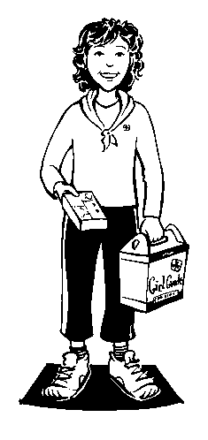
GGC-QC Cookie Ribbon Order Form

Campaign:

- Spring
- Fall
- 2013
- 2014

Name of Unit:
Name of Guider submitting request:
iMIS number:
Please send cookie prizes to:
Full name:
Street address (including Apt. #):
City:
Postal Code:

Girl’s Name* | iMIS #* | # boxes sold* | Previous total | Last crest received | Grand total** | Prizes**

*Mandatory Fields
**For office use; if you have this information, please include it to ensure consistency. In the case of discrepancy you will be contacted.

Please send completed forms to cookies.biscuits@guidesquebec.ca

