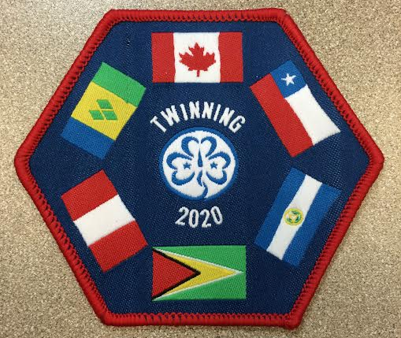
Alberta Council Twinning 2020 Challenge Crest

The following requirements need to be met in order to earn the Twinning Crest:
Participate in 2 of the following:
- Play the WAGGGS World Thinking Day 2015 Game
- Share the Guiding Light World Thinking Day 2015 by either
  - posting a photo on Twinning 2020:Guyana & Alberta Council Facebook Group Page
  - Sending a photo to twinning@albertagirlguides.com
- Participate in one or more of the activities from the Guyana Instant Meeting on the provincial website
- Participate in any International Day of the Girl 2015 activities TBA
- Participate in World Thinking Day 2016 activities TBA

