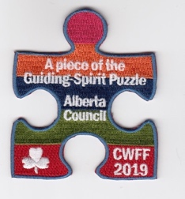

CWFF 2019
The International Committee challenges each member of the Alberta council to learn about International Guiding, and how Girl Guides of Canada is connected to WAGGGS. There are 3 parts to this challenge: CWFF, Thinking Day and Organizational Awareness (WAGGGs and GGC).
The purpose of this challenge to raise awareness of CWFF and raise money for this long standing and worldwide Guiding tradition.

All branches must complete Section #1 – CWFF. Sparks and Brownies complete 2 other activities from other sections. Guides, Pathfinders and Rangers complete 4 other activities from the other sections. To purchase this year’s crest email orders@albertagirlguides.com
after you have completed the sections in this challenge.
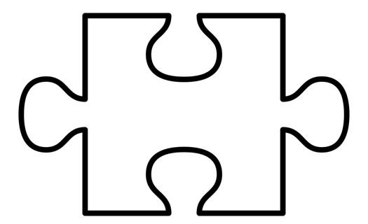
WAGGGS
GGC
Thinking Day
CWFF

SECTION #1 – CWFF
Through the Canadian World Friendship Fund (CWFF), Girl Guides of Canada is able to support projects in developing countries designed to improve the lives of girls and young women and their communities. Contributions to the CWFF also supports Canadian girls and women who attend international events.
All members (Girls and Guiders) contribute $5 to their Area for CWFF.
Suggestion – see Appendix 1 for an example of a kindness calendar to have girls earn money
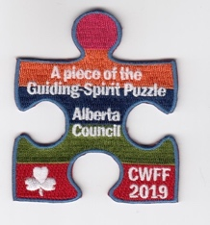

SECTION #2 – Thinking Day
In 1926, Girl Guide and Girl Scout delegates from around the globe met in the USA for the 4th World Conference. Among other decisions, they agreed that there should be a special annual day when Girl Guides and Girl Scouts around the world think of each other and express their thanks and appreciation for our international Movement. This was called Thinking Day. The delegates chose 22 February as the date for Thinking Day because it was the birthday of both Lord Baden-Powell, founder of the Boy Scout Movement, and Olave Baden-Powell, who was World Chief Guide (WAGGGS, 2019).

Each year, WAGGGS publishes a World Thinking Day Activity Pack
https://www.wagggs.org/en/what-we-do/world-thinking-day/badge/
- Discuss what Thinking Day is and the importance of the Day.
- Plan and host a Birthday celebration to honour Lord and Lady Baden-Powell.
- Complete activities from the World Thinking Day Activity Pack.
SECTION #3 – Organizational Awareness (WAGGGS & GGC)
The World Association of Girl Guides and Girl Scouts is the largest voluntary Movement dedicated to girls and young women in the world. Our diverse Movement represents ten million girls and young women from 150 countries. Girl Guides of Canada – Guides du Canada, is the Canadian organization.
There are programmes in five WAGGGS Regions: Africa, Arab, Asia Pacific, Europe and Western Hemisphere. Leadership events at their five World Centres: Our Chalet in Switzerland, Sangam in India, Pax Lodge in the UK, Our Cabaña in Mexico and Kusafiri, the World Centre travelling around Africa.

- Learn about the logos of WAGGGS and GGC. How are they similar? How are they different?
- Plan a virtual trip to one of the World Centres!
- Research the different opportunities that WAGGGS offers to Girls, young adults and Guiders.
- Each country has its own unique flag, borrow flags of WAGGGS countries and hold an International Flag ceremony.
Other Important Links and Resources:
International Flags from Alberta Council
International Committee Trip Planning Brochure
Volunteer at a World Centre
Girl Guides of Canada International Travel Opportunities
Thinking Day Activity Pack
WAGGGS

APPENDIX 1 -
Girl Guides of Canada is a part of a larger organization called World Association of Girl Guides and Girl Scouts (WAGGGS) which has over 10 million Girls across the world! We celebrate the founder of Girl Guides and Girl Scouts, Lady Baden Powell, every year on February 22, also known as Thinking Day!

The challenge from the Alberta Council is to earn $5 per member. These funds are then donated
to the Canadian world friendship fund. This fund allows our organization to support International
Guiding and provides support for all of our members at world events, such as the World Congress
as well as annual national trips!

Our challenge to our ____(unit name)______ is to complete the daily challenge, and help raise funds!

Thursday | Friday | Saturday | Sunday | Monday | Tuesday | Wednesday | Thursday
Today is Thinking Day! We will be doing lots of fun activities to celebrate.  Double your dues to show support | As a Girl Guide, it is important to help around the house! Shhh..see if you can clean something up without being asked! | Spring is almost here, but there is still snow on the ground. Go outside and help clean a sidewalk. | Do you read books? Today read 2 books to a family member: sister, cat, mom, dog or even a fish! | Crafts are fun, it’s even more fun to give them away. Make a special card for someone and give it to them. | Guess Who, crazy 8’s, Go fish or tic tac toe – spend some time with a family, and play a game together! | Hopefully you have been brushing your teeth all week! But tonight, brush for an extra 30 seconds! | Double your dues  Talk to a friend at school about being a Spark or even wear your uniform to school!
$1 | $0.50 | $0.50 | $0.50 | $0.50 | $0.50 | $0.50 | $1

Check off the days you completed and return to our next meeting! Name:__________________________

