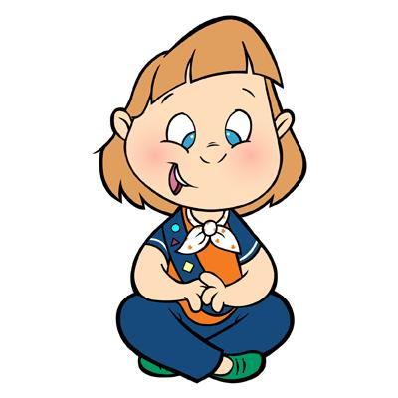

Re: Girl Guides of Canada – Guides du Canada

Are you a woman 19 or older with a zest for life, a desire to help girls, a wish to make new friends and have some fun? Guiding may be just the thing for you.

The Girl Guides of Canada-Guides du Canada have been a part of our community for over 100 years and yet the values and skills we offer to girls are as more relevant today than ever before. Girls make friends, gain useful skills, learn about the environment, participate in community activities, have fun, gain self esteem, confidence and healthful habits while playing games, singing, camping, earning badges in the arts and sciences, the outdoors, the community and the world. For older girls and adults there are opportunities to travel, to attend large camping events in BC and across Canada and to make international friends. Scholarships and bursaries assist girls and women to upgrade their skills and education.

Ours girls range in age from kindergarten to 18 years old. Most groups meet once a week for an hour or two depending on age. A wonderful and varied program is provided for each level and adults can chose the activities to suit the community, time of year, resources available, interest, etc. We need women to be leaders, resource people, treasurers, council members, campsite members, etc. Along the way you will have fun and make friends.

- Sparks are 5 and 6 years old and meet for an hour a week. They begin to explore the community and learn to work together.
- Brownies are 7 and 8 years old and meet for 1 ½ hours. No two meetings are alike but they earn badges, go camping and explore the world around them in a safe, inclusive environment.
- Guides are 9, 10 and 11 years old and learn new skills and explore new interests. They may go camping or hiking and will gain skills and confidence that will serve them well in the future.
- Pathfinders are 12 to 14 years old and the emphasis is on friendship and the talents of each girl. At this age they may go on a trip or attend a large event in Guiding.
- Rangers are our older teens and although they do plan their program themselves they still need adult assistance, role models and guidance.

If you think Guiding may be for you please call us and we will put you in touch with the local Guiders. We will require an application form, police record check and references. We offer required training in Safe Guide and Orientation to Guiding as well as many other interesting and informative topics.
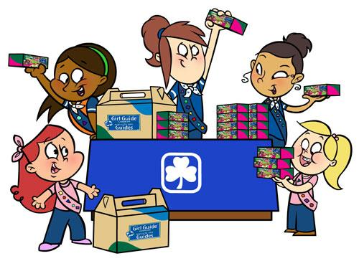
Contact: 1-800-565-8111
E-mail: info@bc-girlguides.org
Website: www.bc-girlguides.org

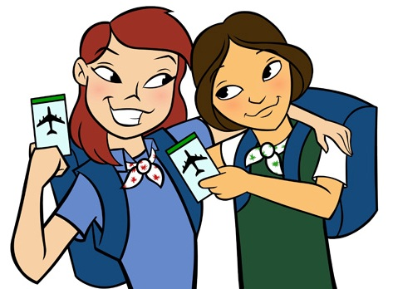

Girl Greatness Starts Here

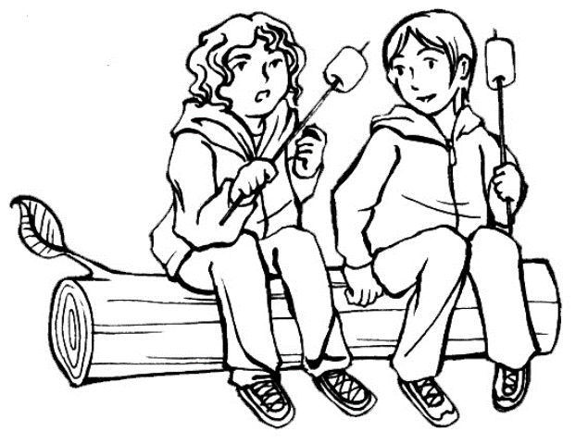
Girl Guides of Canada-Guides du Canada
Information for women
Join the Girl Guides
Call 1-800-565-8111
Girl Greatness starts here

