Dear Parent or Legal Guardian

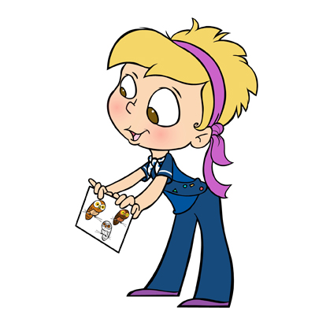When your daughter starts school in September she will be the right age to join a group of 9, 10 and 11 year olds know as Girl Guides, the original branch of Girl Guides of Canada-Guides du Canada. The Girl Guide Program introduces girls to a wide variety of activities and allows them to try new things, make new friends, learn about the world and challenge themselves, gaining new skills and experiences in a safe environment.

In Guides, the emphasis is on developing friendship and learning about the world, while also exploring the individual talents and skills of each girl in the unit. Through a program that offers a variety of challenges in the outdoors, the arts and sciences, the community and the world the girls earn badges, have fun and gain skills which will serve them well in the future.

Some activities might include:
- Helping at a local food bank
- Starting a book club or joining the online club on our website for girls
- Planning a tree planting project
- Learning about online safety
- Working on our anti-bullying challenge
- Planning a special activity
- Camping, hiking, outdoor activities
- Pursuing a special interest badge such as photography or event planning

Always fun and never boring – that’s what Guides is about.

Guides begin to think of themselves as part of the wider community and make friendship that will last a lifetime. Guide units usually meet once a week, girls wear a uniform and earn badges.

To register go to our National website at www.girlguides.ca and click on Join Us. The Unit Finder will help you to find a group near you. If you need a paper application or wish to know more about Guides, becoming a leader, or another branch of Guiding, please call or e-mail our Provincial Office and we will be pleased to assist you. Membership in our organization is open to adult females and girls over the age of five years. Come join us!
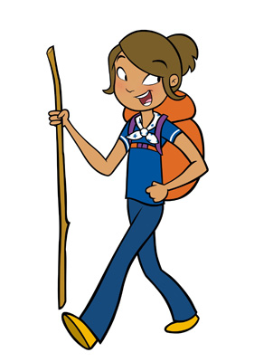
Contact: 1-800-565-8111
E-mail: info@bc-girlguides.org
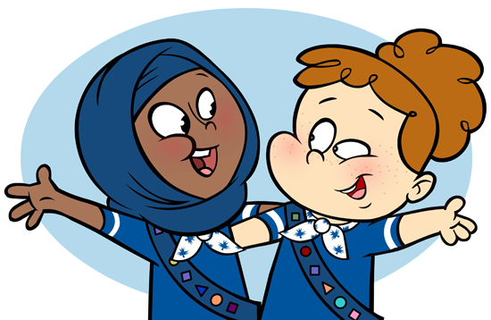Website: www.bc-girlguides.org
Girl Greatness Starts Here

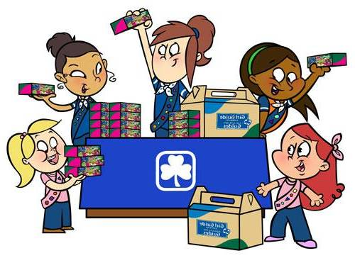
Girl Guides of Canada-Guides du Canada
Information for girls age 9, 10 and 11
Guides
Call 1-800-565-8111
Girl Greatness starts here

