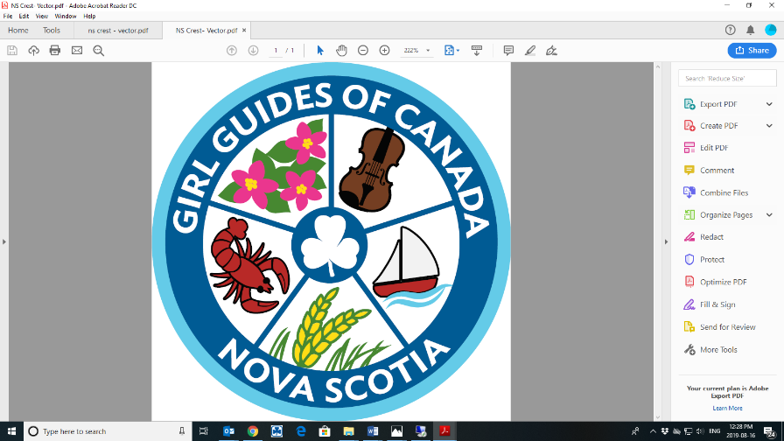

NOVA SCOTIA MERCHANDISE

Want a memento of your Guiding fun…………

Then why not order a T-shirt, long sleeve shirt, sweatshirt, or all!!

Girl Guides of Canada, Nova Scotia is pleased to advise that we have partnered with a local company, to be our preferred merchandise supplier for our provincial outdoor experiences and events.

When ordering please refer to the size chart to help you choose the correct size.

How to order: Complete the order form along with the following information:
- Choose item(s) Select size and color and:
- Forward order form to ns-ggc@girlguides.ca.

Payment options:
- Cash & Debit accepted at the Provincial Office.
- Credit card (Visa / MC) accepted via phone (902-423-3735)
- Send Chq or Money Order to the office with order form:
(3581 Dutch Village rd. Halifax, NS B3N 2S9)

Fine Details:
- No refund or exchange of items, unless manufactures defects.
- GGC is not responsible for garment(s) ordered in the incorrect size – refer to Size Charts.
- Orders will be held and placed once the minimum requirement is reached.
- Orders will come to the Provincial office – you will be notified for pick up or shipping.

NOVA SCOTIA MERCHANDISE
(samples for reference only, NS crest will be at and colors will match description)

SHORT SLEEVE T-SHIRTS: $10 each + tax
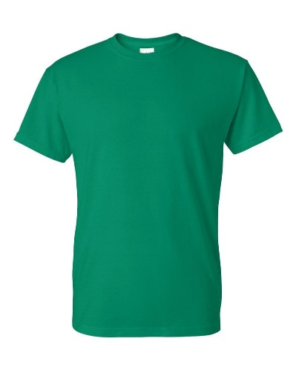 | 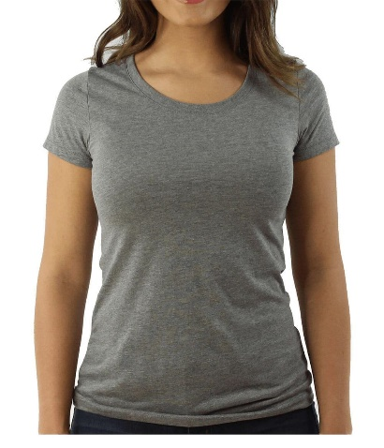 | 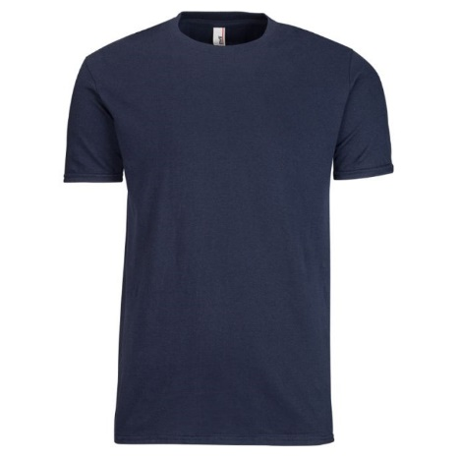
Order #ATC1000Y | Ladies- Order # ATC1000L | Adult- Order # ATC1000
100% cotton, crew neck short sleeve t-shirt. Printed NS Crest front and GGC logo on sleeves.
Colours: Navy , Kelly Green, Sangria, and Grey

LONG SLEEVE SHIRTS: $15 each + tax
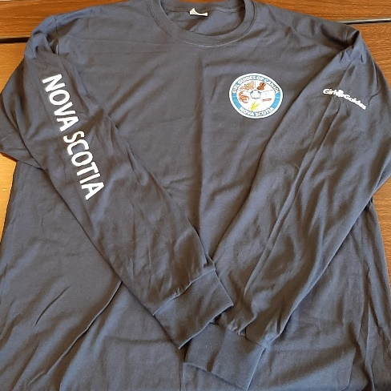 | 100% cotton, crew neck long sleeve t-shirt,  Printed NS Crest front; Nova Scotia and GGC logo on sleeves.  Colours: Navy Only  Youth- Order #ATC1015Y  Adult- Order #ATC1015

HOODIES: $30 + tax | HOODIES: $30 zippered front + tax
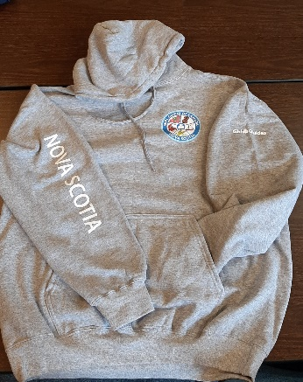 | 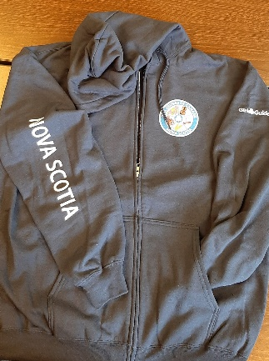 | 50/50 cotton/polyester fleece hoodie  Printed NS Crest front; Nova Scotia and GGC logo on sleeves.  Colours: Navy, Grey
Youth- Order # ATCY2500  Adult- Order # ATCF2500 | Youth Zippered Front- Order # ATCY2600  Adult- Zipper Front – Order # ATCF2600

