NOVA SCOTIA CONFERENCE 2019 MERCHANDISE

Want a memento of your Conference fun…………

Then why not order a T-shirt, long sleeve shirt, sweatshirt, or all!!

Girl Guides of Canada, Nova Scotia is pleased to advise that, a local company: Chandler Sales, will be our preferred merchandise supplier for our provincial outdoor experiences and events.

When ordering please refer to the sizing chart (available at www.girlguides.ca-> Conference) to help you choose the correct size.

We’re starting off with event orders only. Conference attendees will have the opportunity to order items and pick them up at the event. In 2020 we will expand to include Kwahee and Spark Brownie Camp.

To avoid disappointment, please note order deadline of Oct 3rd 2019.

How to order: Complete the order form with the following information:
- Choose item(s) Select size and color and:
- Forward order form to ns-ggc@girlguides.ca.

Payment options:
- Cash & Debit accepted at the Provincial Office.
- Credit card (Visa / MC) accepted via phone (902-423-3735)
- Send Chq or Money Order to the office with order form:
(3581 Dutch Village rd. Halifax, NS B3N 2S9)

 |  | 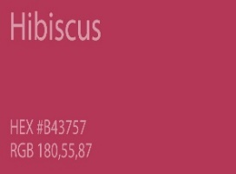
Navy | Kelly Green | Sangria | Grey
Color Chart:
Fine Details:
- No refund or exchange of items, unless manufactures defects.
- GGC is not responsible for garment(s) ordered in the incorrect size – refer to Size Charts.
- No guarantee of availability on orders received after Oct 3rd, 2019 due to minimum quantity requirement.
- Every effort will be made to have the orders received, by the order deadline date, ready for pick up at the event.

NOVA SCOTIA MERCHANDISE
(samples for reference only, Conference crest will be at and colors will match description)

SHORT SLEEVE T-SHIRTS: $10 each + tax
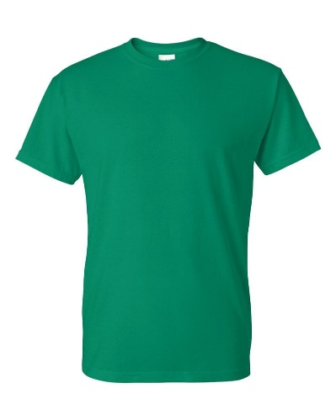 | 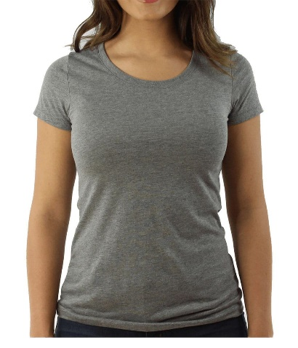 | 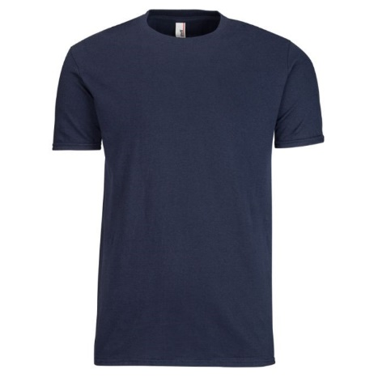
Order #ATC1000Y | Ladies- Order # ATC1000L | Adult- Order # ATC1000
100% cotton, crew neck short sleeve t-shirt. Printed NS Crest front and GGC logo on sleeves.
Colours: Navy , Kelly Green, Sangria, and Grey

LONG SLEEVE SHIRTS: $15 each + tax
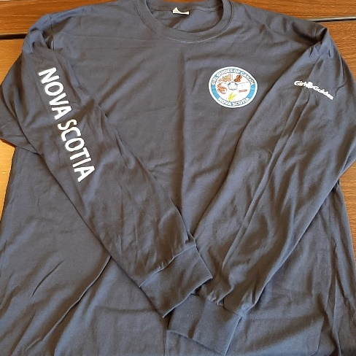 | 100% cotton, crew neck long sleeve t-shirt,  Printed NS Crest front; Nova Scotia and GGC logo on sleeves.  Colours: Navy Only  Youth- Order #ATC1015Y  Adult- Order #ATC1015

HOODIES: $30 + tax | HOODIES: $30 zippered front + tax
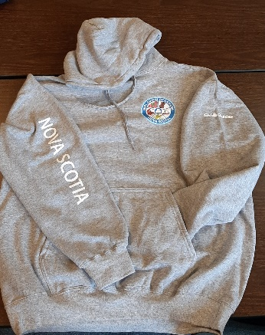 | 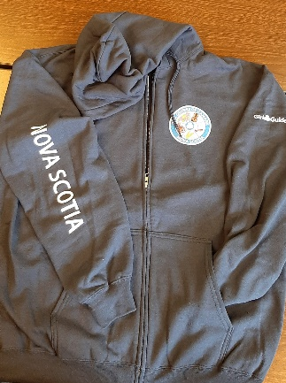 | 50/50 cotton/polyester fleece hoodie  Printed NS Crest front; Nova Scotia and GGC logo on sleeves.  Colours: Navy, Grey
Youth- Order # ATCY2500  Adult- Order # ATCF2500 | Youth Zippered Front- Order # ATCY2600  Adult- Zipper Front – Order # ATCF2600

