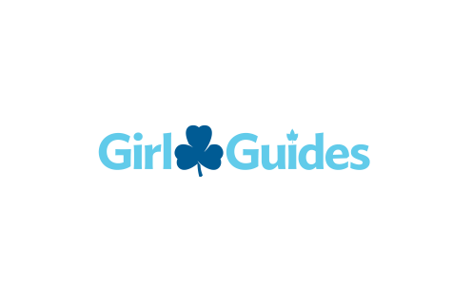

THANK YOU FOR SUPPORTING GUIDING IN ONTARIO AND NUNAVUT!
I’ve enclosed my cheque made payable to Girl Guides of Canada, ON.
Donation Amount: | $25 |  | $50 | $100 |  |  | Other: $ | Note: Donation receipts will be issued for gifts of $20.00 or more.
In Support of: | Unit Name: |  |  |  |  |  |  |  |  | Bank ID: |  | Amount: $
In Support of: | Unit Name: |  |  |  |  |  |  |  |  | Bank ID: |  | Amount: $
In Support of: | Unit Name: |  |  |  |  |  |  |  |  | Bank ID: |  | Amount: $
In Support of: | Other (if specific purpose, please describe):
DONOR INFORMATION (FOR DONATION RECEIPT)
NAME |  |  |  |  |  | IMIS NO. (Members Only) |  |  | ORGANIZATION NAME
ADDRESS |  |  |  |  |  | CITY |  |  |  |  | PROVINCE |  | POSTAL CODE
Special Instructions and Requests: |  | I wish to remain anonymous. |  |  |  | Other:

PLEASE MAIL TO: | CONTACT US:
Girl Guides of Canada  Accounts Receivable ON  100-180 Duncan Mill Rd  Toronto, ON M3B 1Z6 | EMAIL: accountsreceivable@girlguides.ca

