Dear Parent or Legal Guardian

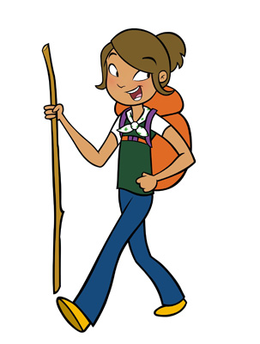When your daughter starts school in September she will be the right age to join a group of 12-14 year olds know as Pathfinders, the branch of Girl Guides of Canada-Guides du Canada for younger teens. The Girl Guide Program introduces girls to a wide variety of activities and allows them to try new things, learn about themselves, the community and the world while gaining skills and experiences in a safe environment.

In Pathfinders, the emphasis is on developing friendship, trying new things and learning by doing with other girls their age. Pathfinders learn about the world, while also exploring the individual talents and skills of each girl in the Unit. Through a varied program that offers a variety of challenges in the outdoors, the arts and sciences, the community and the world the girls meet challenges, have fun and gain skills which will serve them well in the future.

Some activities might include:
- Learning about healthy relationships and building self-esteem
- Creating decorating ideas for your personal space
- Having discussions about meaningful topics such as body image and media
- Taking an international trip or participating in a large camping experience
- Planning and holding a special event
- Leading activities for younger girls and gaining leadership skills

Looking for extra adventure – Trex Units focus on large projects, trips or adventures

Pathfinders begin to think of themselves as part of the world community and make friendship that will last a lifetime. Pathfinder Units usually meet once a week. The girls wear a uniform and choose topics from a wonderful program

To register go to our National website at www.girlguides.ca and click on Join Us. The Unit Finder will help you to find a group near you. If you need a paper application or wish to know more about Pathfinders, becoming a leader, or another branch of Guiding, please call or e-mail our Provincial Office and we will be happy to assist you. Membership in our organization is open to adult females and girls over the age of five years. Come join us!

Contact: 1-800-565-8111
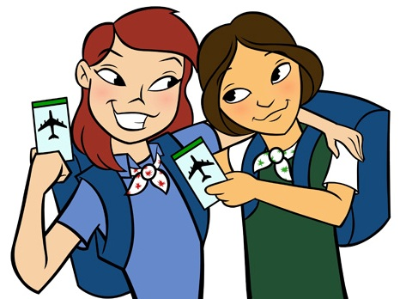E-mail: info@bc-girlguides.org
Website: www.bc-girlguides.org

Girl Greatness Starts Here

Girl Guides of Canada-Guides du Canada
Information for girls age 12 to 14
Pathfinders
Call 1-800-565-8111
Girl Greatness starts here

