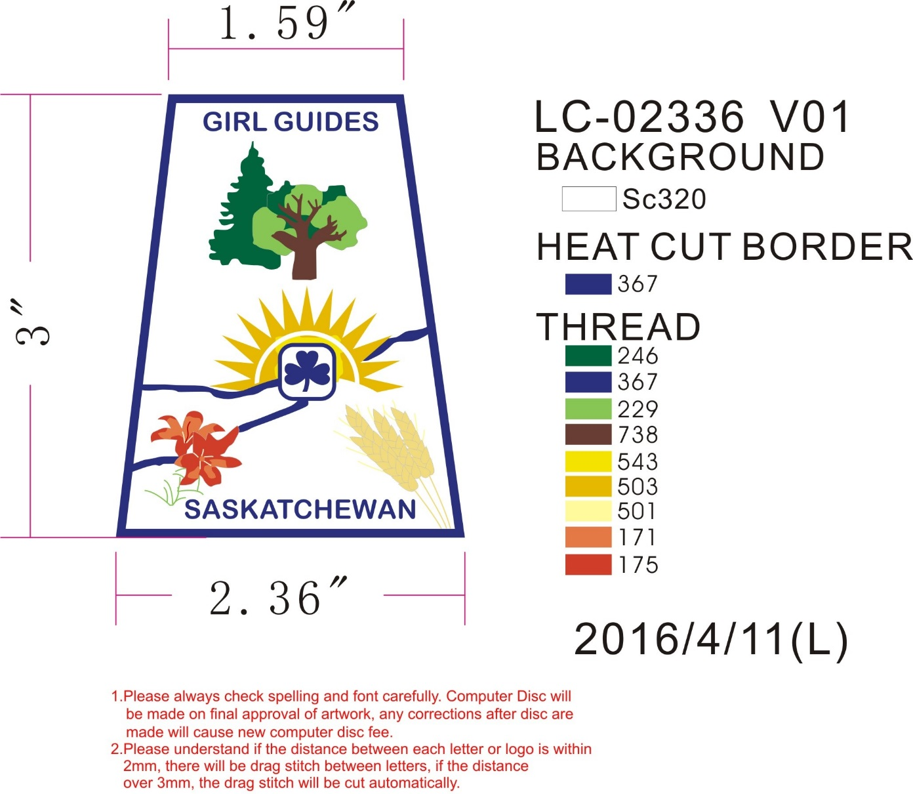

Now available through the Provincial Office

75 CENTS PER CREST