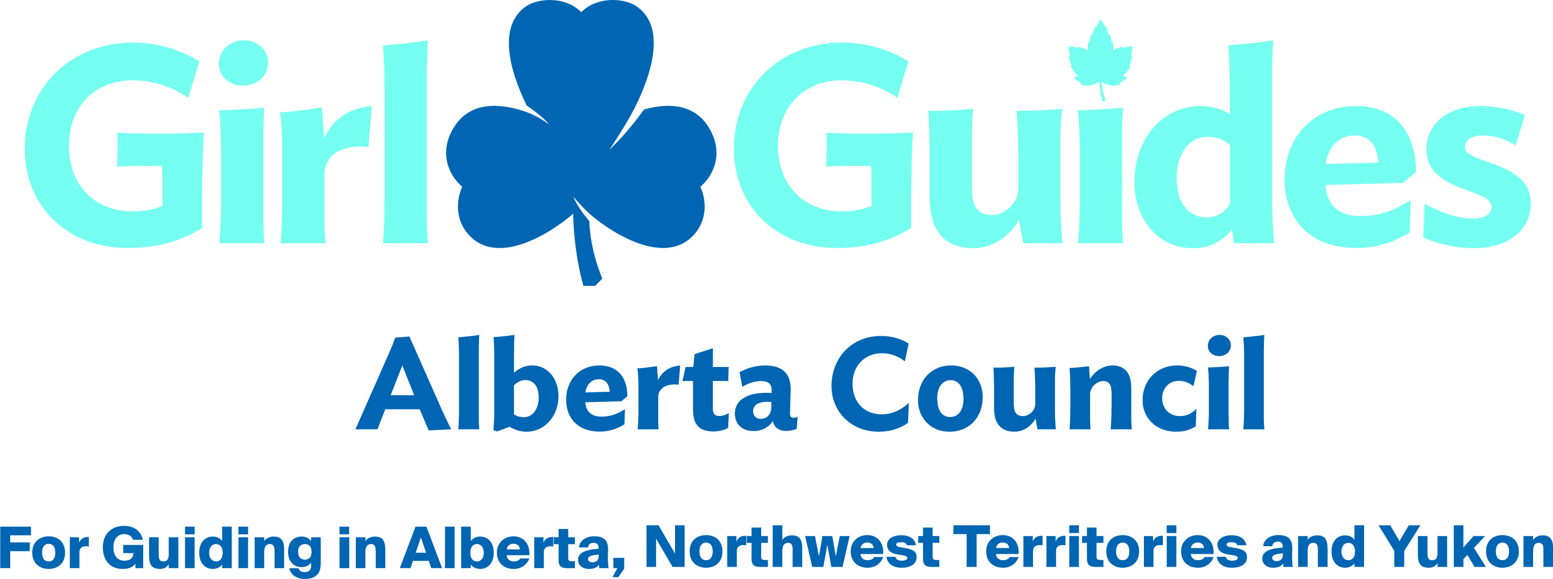
Transitioning Members
A Guide for leaders, Commissioners and iMIS homes

We are always delighted when our young women participating in Rangers want to complete their program and continue on to become leaders in Girl Guides of Canada. We may not always be sure of the correct way to register and enter these YMBRs (youth members) in iMIS, and this document has been created to clarify some of those points.

We have three common scenarios with this Guiding demographic:

a) Rangers who are 17 at the beginning of the Guiding year, but will be turning 18 at some point before the Guiding year is over, who wish to finish their Ranger program.

- The Ranger program is designed for young women aged 15 – 17 years of age.
- A girl (YMBR) may register as a youth member in a Ranger Unit at age 17 to complete her program and pay the usual girl registration fee, as long as she has not yet turned 18 by the start of the Guiding year (Sept 1st).

b) Rangers who have finished their Ranger program, and have already reached the age of majority prior to the start of the Guiding year (Sept 1st).

- At the end of the Guiding year, a YMBR reaching the age of majority where she lives must proceed with an adult screening process and become a Potential Member if she is going to be working with the girls in an adult capacity. As she will be cancelled on August 31st, having reached the end of the previous year’s registration period, she will need to make arrangements, with the help of her district leaders, to begin her screening process before that August cancellation date. Area and the Alberta Council offices are open during all or most the summer and can help leaders or the applicant herself with any questions.

c) Our third scenario is Rangers who have completed the Ranger program, but who have not reached the age of majority by the start of the Guiding year (September 1st) – their birthday comes at some point during the Guiding year. They cannot register in Rangers, but they are too young to be an adult leader yet.

- A young woman who is reaching the age of majority in September or later - after the Guiding year has started - will be listed as a “Transitioning Member.”
By definition, a Transitioning Member (TMBR) is a youth member who has not yet reached the age of majority in her province/territory but has completed the Ranger program. Age of majority in Alberta is 18, and 19 for Northwest Territories and Yukon.

- A TMBR is still a youth member and as such, has “girl” status, as opposed to “adult” status in Guiding. Because of this, she will need to submit a paper A.5P registration form to her iMIS home, to continue to be active in Guiding.
In the top section of the A.5P form, where it says “I want to join,” select the option “Girls transitioning to adult membership (completed Rangers program).”

- As a TMBR, she can work with a unit and would be listed in iMIS as having an activity as a “Girl Assistant” in a Spark, Brownie, Guide, or Pathfinder Unit. She may not work with a Ranger unit, as there is a requirement of a “one branch separation” for all girl assistants.

As a “Girl Assistant” a TMBR may not act in the capacity of an adult supervisor during this time, except under certain circumstances – refer to Safe Guide manual.

- As a TMBR, if she is not working with a unit, she would have an activity as a Girl Member at Large and her Area would be her home council in iMIS.

- A TMBR must proceed with the adult screening process once she has reached her 18th birthday. She will need to submit a signed A.1 to her iMIS home to begin that processes as soon as possible after her birthday – within one month is recommended. If she does not register within 3 months of being moved to the status of Transitioning Member, her membership and activity will be cancelled by her iMIS home, following consultation with the Area Commissioner. Once the girl is an adult, her District Commissioner is responsible to ensure that she is not working with a unit until she has a PRC entered in the iMIS system.

- A TMBR cannot be registered as a Link member, as this is an adult activity.

A note to Leaders regarding TMBRs and the Screening Process:

If a young woman is cancelled in iMIS before she begins her adult screening process (cancelled August 31st as all unregistered girls are, and her birthday comes more than a month after Sept 1st), then to become a PMBR she must then complete the whole screening process like any other new member. (See the S.1 form – her category, of those listed, would be “cancelled girl member.” (S.1 choices are: New member; Returning member* absent more than 2 years; Cancelled girl member.”)

In order for a young woman to move into her adult screening process needing less of the screening package elements, she must be ACTIVE (registered with an A.5P) in iMIS when the process is started. (S.1 form – her category would be “Active girl member transitioning to adult member”). A youth member who was cancelled at the end of August cannot come back several months later and be considered as a “transitioning member.”

A note about Billing/Fees:
If a Transitioning Member (TMBR) does not turn 18 until after the National billing date, then the area will get charged for her as a girl, however they would not get charged twice in the same year (once as a girl and once as an adult) if she later becomes an adult member, as the system recognizes that is has already billed for that iMIS number.
For iMIS Homes: Entries & Tracking for Transitioning Members

iMIS entry for TMBRs
A Transitioning Member is still considered as a youth member, however you will need to change the membership type field from “YMBR” to “Transitioning Member.”
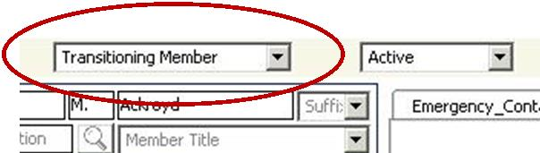

TMBRs who are Girl Assistants
For a TMBR, the girl unit that she is working in would be her home council in iMIS.
She would not need any notation in the “events” module, as she is not taking a registerable space in the unit in which she is helping.

TMBRs who are Not Helping in A Unit
These TMBRs would be designated as a “Girl Member at Large” and it is an activity category of its own like “Ranger” or “Girl”. Her home council would be at the area level.

Tracking TMBRs
An Access Report exists that will show all TMBR within a province, allowing the provinces the ability to support these young women before they become adult members.
In Access Reports:
Select “Rosters & Directories”
Choose “Member Roster Report – Multi Level”
Put in your province (9) and area iMIS number
Unclick all the boxes on the right column listing
Check off ONLY “Transitioning Members” in that column
Select “Report: Alpha”

Supporting TMBRs
Our young transitioning members often have challenges with some parts of the screening process, like the “electronic identification verification” element of BackCheck. It would be helpful as an iMIS home to touch base with the District Commissioner and see if there is anyone specifically assigned to work with a transitioning young woman, so that you have an additional contact person as the TMBR goes through the screening process.

