Girl Scouts of Western Washington – Whatcom County Girl Scouts present
MIX IT UP 2014
“Games Through the Years”
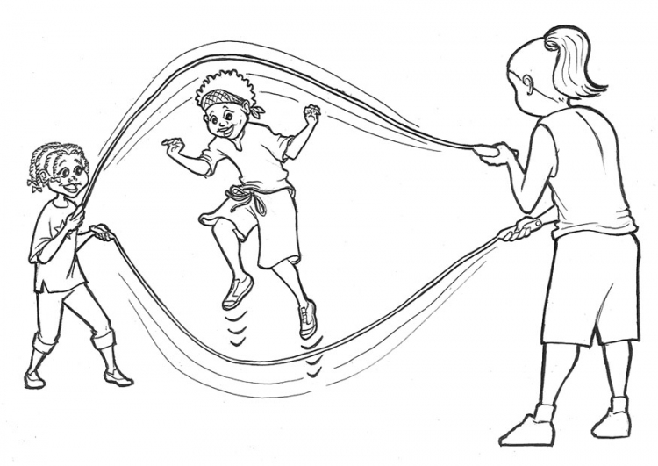
12th Annual Girl Scout & Girl Guide Encampment
September 19 – September 21, 2014
For Girl Scout Juniors and Cadettes, Guides and Pathfinders

EVENT LOCATION: GSWW Northern Property, 9010 Heady Road, Sumas WA 98266

COST: $28.00 USD PER PERSON (Girls & Adults) – NO REFUNDS
In case of illness replace girl or adult with alternate

ACTIVITIES: Games old and new, challenge dinner, mixers & more. Come and make new friends!

FEE INCLUDES: Two nights camping, all activities on site, challenge dinner, Sunday breakfast, t-shirt and patch. This is a tent camping event, appropriate for experienced campers. Patrols must provide own food and equipment, including tents and cooking gear.

ARRIVAL AT CAMP: Friday, September 19th between 6:00pm and 9:00pm

CLOSING: Sunday, September 21th by noon

REGISTRATION: Send registration form and check in US funds (payable to GSWW SU 120 Events) to: Mix It Up 2014 c/o Wendy Crandall 926 12th Street, Bellingham WA 98225. NO LATER than May 15, 2014. Registration is limited to first 35 patrols.

CONFIRMATION: We will send you further information and equipment list upon receipt of your registration and payment. Contact Wendy Crandall at wendycrandall@gmail.com for more information.

Unit (including District)/Troop: | Area/Service Unit #:
Responsible Guider/Leader:
Full Address:
Email: | Phone #:
Accompanying Guider/Leader:
Full Address:
Email: | Phone #:
Emergency Contact (during event): | Phone #:

Names of Participants | T-shirt Size  Adult S-XXL | Age
Leader:
Leader:
Girl 1:
Girl 2:
Girl 3:
Girl 4:
Girl 5:
Girl 6:
Girl 7:
Girl 8:

