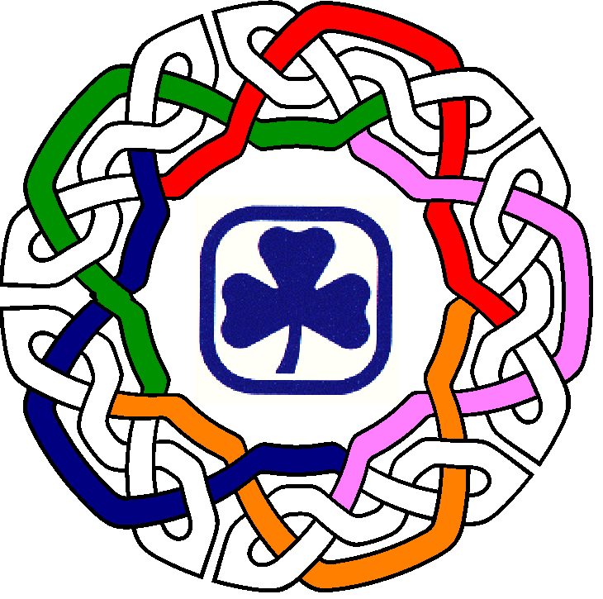
YOUTH COMMITMENT AWARD
Nova Scotia

The Nova Scotia Youth Commitment Award provides an opportunity for NS Ranger Members to be recognized for their commitment to our Organization.
Tying the award to Nova Scotia's Celtic heritage, the Pin is based on the Celtic knot. The knot has special meaning as it is unending - symbolically a nice way to think about Guiding and its ongoing effect on the lives of youth who have gone through the program. The colours of the five branches have been incorporated to show how all of the branches are linked together and touch one another throughout. The uncoloured parts are representative of the areas of our lives that Guiding touches.
- The Unit Guider is responsible to arrange for presentation of the Award.
- The Award is to be presented to Rangers in their 12th or 13th year of Guiding, either at one of the Youth Recognition Ceremonies or at the Guiders discretion.
- It is only presented once and may be worn on the pin tab as an adult member.
- The Registration Form for the Youth Recognition Event(s) will solicit information for presentation at the event or for announcement of a previously presented award.
- Areas will be invoiced for the Awards.

To order the Award, please complete the Youth Commitment Award Order Form and submit to ggcns@girlguides.ns.ca
