Girl Guides of Canada – Guides du Canada

Nova Scotia Provincial Recognition and Awards – The Tartan

A Handy Reference Guide for
Nova Scotia Guiders



- Internal Awards
- External Community Awards

Feb 5, 2008
Rev: Oct 2008
Rev: Jan 2010

TABLE OF CONTENTS
Description  How to Apply for an Award for Members……………………………………  Common Requirements for All Awards….………………………………………….  Application/Approval/Purchasing of Awards Process……………………………….  Suggestions for Those Who Are Completing Applications………………………….  A “Suggested Only Format” for Supporting Letters………………………………...  What do I write in a letter of support for an award? …………………………………  Sample Support Letter………………………………………………………………..  Award Application Screening Checklist (optional) …………………………………  Q & A’s………………………………………………………………………………  Awarding Council & Approval Check list……………………………………  Recognition of Years in Guiding…………………………………………………….  Awards……………………………………………………………………………….  Awards for Supporters of Guiding …………………………………………………..  Approved Area Awards ……………………………………………………….…….  Chief Commissioners Bursary Information……….………………………………...  References …………………………………………………………………………...  Canadian Awards…………………………………………………………………….  Adults Award Form R3- Tips for Completion……………………………………… | 3  4  5-6  6  7  7  8  9  10  11  12  13-16  17  18  18  18  19-20  21-22

INTRODUCTION

ONGOING RECOGNITION

FORMAL AWARDS - HOW TO APPLY FOR AN AWARD FOR ADULT MEMBERS
Awards information governing adult members is found in Guiding Essentials, Standards at a Glance, December 2006.
The presentation of awards to Guiders is a vital way of recognizing their contributions in a more formal way. Awards are given to honour the recipient. Everyone is encouraged to present them regularly to show how much our Guiders are appreciated. Never wait until a job is finished to offer recognition. Please be sure to show recognition and thanks in many other informal ways over and above these official awards.
There are District, Area, Provincial and National awards. Area Awards Committees/ Councils should be encouraging the various Councils to give awards at every level and reminding them not to wait for Guiders to retire or move away, etc. Councils can never thank their volunteers enough. One of the best recruitment tools we have is giving the appropriate award at the appropriate time. The most important thing is to apply!
District Awards are processed through the District Council level. The Area Awards are processed through the Area Council/Area Awards Committee/Area Commissioner.
Applications for Provincial and National Awards are forwarded to the Provincial Executive Committee through the Executive Assistant at the Provincial Office. Please see Awarding Council & Checklist or each category in this document for details.
For Provincially approved awards, the information should be forwarded from your Area Commissioner/Awards Committee to the Provincial Executive at least 6 weeks before the planned presentation date in order to allow time for processing of the application.
For awards approved by National, Guiding Essentials recommends that National Council be given at least three months notice before the award is to be presented.
Please keep in mind that Area and Province must receive the information prior to the National Council.

REQUIREMENTS FOR ALL AWARDS
- Awards should be given by the Council that is most influenced by and involved in the work for which the Guider is being recognized. For example, a District Council might wish to give a Gold Thanks Pin, Team Award, Bronze, Silver, or Gold Merit Award for work at the unit or District level. The District Council is then responsible for carrying out the Awards Process. If a Guider is working at the Area, Provincial or National level and those levels wish to acknowledge her efforts then the appropriate level will initiate and carry out the Awards Process.
- The Application for Recognition of Adult Service Awards Form (R.3) must be completed for all adult awards and have the appropriate signatures. The applicant may also write a letter of support if desired. The more information received the better. The Guider will really enjoy reading the letters of support and will know her efforts have been appreciated. Letters should contain details about the Guider and current information, detailing her accomplishments since she last received an award. This booklet contains a sample letter outline on page 9.
- Awards may be applied for at any time during the year. However, check with the Area to find out whether there are special events when awards will be presented. Processing applications can be time consuming when a large number arrive too close to a presentation date.
- Awards can be given more than once to any member.
- Awards can be presented at any suitable function and in any order. If uncertain, use the wording that describes the service of the award as a guideline or use the order as presented in Guiding Essentials.

Application for Recognition of Adult Service Awards Form (R.3) can be found on the National Web Site:
www.girlguides.ca
(MemberZone site)
Or, contact your District/Area Commissioner.

Recognition of Years in Guiding
Membership Pin

All girl and adult members of Girl Guides of Canada-Guides du Canada receive a Membership pin. The Membership pin indicates the number of years of membership to the organization and only one Membership pin is worn at a time. Girls receive their Membership pin from their Guider or Commissioner and women receive their pin from their District/Area/Provincial Commissioner. Pins are provided at the beginning of the year.

50 + Years of Membership

Letters of recognition from the Chief Commissioner are sent to women with 50 years of service and every five years after that.

Application/Approval of Awards Process
If District is presenting the Award:
- A Guider sends her recommendation (R.3) to her District Commissioner.
- The District Council reviews the R.3, letters of support, approves the recommendation, buys the pin & makes the presentation.
- Area Commissioner is notified of Award approval/presentation. (Example: in the District Report to Area Council).
- Paperwork (R.3) is forwarded to Provincial Office attn: Records Management Coordinator for entry into iMIS (follow up for date of presentation entry to iMIS if required) – this statement is too confusing – suggest taking this out.
If Area is presenting the Award: same procedure as for Districts except:
- Guider sends recommendation (R.3) to her Area Commissioner.
- Area Council/Awards Committee reviews the R.3, letters of support, approves the recommendation, buys the pin & makes the presentation.
- Paperwork is forwarded to Provincial Records Management Coordinator for entry into iMIS (follow up re date of presentation if required). See above for comment.
- Awards Chair provides report of Awards approved at Membership Support Committee Meeting. Membership Support Director includes in her Report to Provincial Council.
Provincial Awards: (Mayflower, Medal of Merit and/or any Award being presented by the Provincial Council and/or Awards needing National Approval, for example the Beaver, Honorary Life etc...)
- Recommendation form (R.3) and letters of support are sent to Provincial Executive Committee through the Executive Assistant from the Area Commissioner.
- After paperwork and letters of support have been reviewed, a Motion is made by the Provincial Executive Committee for approval.
- Notification of approval is sent back to the recommending Council for pin purchase and presentation.
- The Provincial Executive forwards the awards information to the Provincial Records Management Coordinator for iMIS updates. (follow up re presentation date if necessary)
- The R.3 and letters of support for Awards requiring National Approval will be forwarded by the Provincial Executive.

Purchasing Awards
It is not necessary to show any documentation to PURCHASE awards. However, it should be noted that an Award will not be included on a Members iMIS Record, unless the appropriate paperwork has been completed and sent to the Provincial Office attn: Records Management Coordinator for data entry into iMIS.

SUGGESTIONS FOR THOSE WHO ARE COMPLETING THE APPLICATION FORM (R.3)
Please visit the National website often to ensure you are using the current forms! Forms are updated frequently, so always check prior to using/sending any form.

1. Collect the information needed to complete the application, including the iMIS profile (contact the Provincial Records Management Coordinator for the iMIS record.).
2. Check to see which awards the recipient has and when they were presented.
3. Determine which award best fits the Guider you want to recognize. Awards are not presented in a set sequence so take time to choose the best one. Consider what other Guiding awards she has received. The Awards Committee will review it based on the “norm” and make a recommendation if necessary.
4. Select individuals to write supporting letters and ask them if they are willing to participate.
5. Choose people who know the Guider in different capacities so that different aspects of her involvement will be noted. Letters from non-members may be added to the Guiding letters to provide an overall picture.
6. Suggest things that each letter writer might include. Remind them that they should include only things since the last award was presented. Consider the information on letter writing below.
7. Give letter writers a deadline to have the letters completed and sent to you.
8. Compile all information requested to support the application and forward it to the Council concerned for local approval. All other councils may be informed out of courtesy. Note: When possible make a copy of everything to keep in case anything is misplaced.
9. The presentation date must be included on the application form. Applications for Provincial Awards without dates will be put on hold until a date is provided.
10. All R.3 and A.4 Forms MUST be sent to the Provincial Records Management Coordinator for iMIS input.

A SUGGESTED FORMAT FOR SUPPORTING LETTERS:
- Identify the person you are writing about.
- State your relationship to that person and how long you have known her.
- Identify two or three reasons why you think she should be recognized.
- Allow one paragraph for each reason and give specific details as they relate to Guiding and the work she does with you. Include words that will be compatible with the key word in the description of the award. Two other people will be writing letters too and will have other experiences to share so you don’t need to tell it all, but don’t understate her skills and accomplishments either. Remember to include only things she has done since she last received a Guiding Award.
- Summarize and close your letter.
- Complete your letter and return it to the individual who requested it in a timely manner. Deadlines are important.

WHAT DO I WRITE IN A LETTER OF SUPPORT FOR AN AWARD?:

1. What has she been doing since she received her previous award? Include as many dates as possible. (The exception would be the Honorary Life Membership when all
service would be considered.)

∼ Has she enriched the girls' program? Give details.
∼ Has she undertaken any special projects? Give details.
∼ Has she taken other Units to camp?
∼ Has she organized rallies, fund raising, church parades and trips?
∼ Has she given extra effort to her Council's activities?
∼ Has she been a role model for other Guiders, especially those with whom she
works most closely?

- Don't forget to include some personal information in your letters as well.
∼ What are her interests in and out of Guiding?
∼ Is she involved as a volunteer in other groups (church, school or other)?
∼ Is she known for acts of kindness?
∼ Does she enrich the lives of others in her community? Give examples.
∼ Does she have a family?
∼ Does she work outside the home, or in a home based business?

The iMIS Profile provides us with the details of service and positions held; the Awards
Committee needs to know why you feel she deserves the award.
Please use a business letter format; if you are unable to type it, be sure it is neatly hand written. Your letter will be read by several people and the original is given to the recipient when she receives the award.

You will find a sample letter to help you write your letter. This is only a sample and is to be used as a guide only! Use your own words and your own experiences with the Guider you are supporting. Every person asked to write a letter of support should be given a copy of both these sample pages - don't assume everyone knows what is expected!

SAMPLE SUPPORT LETTER:

Jan 2008

Dear Members of the Awards Committee,

It gives me great pleasure to write this letter in support of the application for the Medal of Merit for Suzy Q. Guider.

I have known Suzy since 1994; she has given unselfishly of her time and energy to the girls and to Guiding. We have worked together at the Unit level as well as on the
District Council.

Suzy is always the first to "Lend a Helping Hand" when volunteers are needed. In 1996, when the Guider in Charge of the Brownie Friendship Camp took ill and had to leave the position, Suzy volunteered to rearrange her family vacation to ensure that the girls were still able to go to camp.

In 1996, she also became a member of the Quartermaster staff at a Provincial Event. Suzy was "a ray of sunshine" despite the rain that fell every day of the camp! Both the girls and staff will remember her sunny disposition. She played a large part in making this event a wonderful experience for everyone.

In 2000, she agreed to be the chairwoman of an Area event for approximately 1500
participants. Her organizational skills were very evident as everyone enjoyed the day of games, food and fellowship.

In 2001, she sat on the committee for the "Anniversary of Guiding" and ultimately
became responsible for the invitations and food for the day.

Suzy recruits leaders at work and tells all she meets they really are missing something if they are not involved in Guiding. Her positive comments about Guiding make her a great ambassador for our organization.

Suzy's husband and family of two daughters and a son are also very supportive and
involved in numerous activities in which she participates. She is also an active member in her church and community; and in her spare time, she loves to sew.

Suzy is truly deserving of the Medal of Merit.
Yours truly,
Sally Guider or Friend/Clergy/Supervisor
(State your position in Guiding/ your connection to the Guider being nominated for the Award)

AWARD APPLICATION SCREENING CHECKLIST – A scoring guideline only
NAME OF RECIPIENT: |  | AWARD APPLIED FOR:
SCORE | ACCOMPLISHMENTS | SCORE | CHARACTERISTICS
 | UNIT GUIDER |  | VERSATILE
 | MINIMUM 3-5 YEARS |  | FLEXIBLE
 | ATTENDS TRAINING |  | MENTOR
 | PLANS VARIOUS OUTINGS |  | LEADERSHIP SKILLS
 | CAMP CERTIFICATION (OAL) |  | MOTIVATED
 | VOLUNTEERS TO CHAIR VARIOUS COMMITTEES |  | LIVES THE GUIDE LAW & PROMISE
 | MEMBER DISTRICT COUNCIL |  | CARING
 | DISTRICT COMMISSIONER/DEPUTY |  | ENTHUSIASTIC
 | TRAINER /INSTRUCTOR /PRESENTER |  | SENSITIVE
 | AREA COMMITTEE MEMBER |  | CAPABLE
 | PROVINCIAL COMMITTEE MEMBER |  | COMMITTED
 | TREFOIL GUILD MEMBER |  | DEDICATED
 | NATIONAL COMMITTEE MEMBER |  | SENSE OF HUMOUR
 | SUMMER CAMP |  | WARM
 | OUTSIDE INTERESTS |  | WEARS UNIFORM WITH PRIDE
 | VOLUNTEERS OUTSIDE OF GUIDING |  | GOOD ROLE MODEL
 | TOTAL |  | TOTAL
For Councils who may require help in approving applications here is a possible sample award Guideline checklist (OPTIONAL USE ONLY)

1. More check marks/points could be from the “Accomplishments” column.
2. For a Silver Merit Award, there could be a minimum of 6 points.
3. For a Gold Merit Award, there could be a minimum of 8 points and this should include involvement at Provincial level or above.
4. For the Medal of Merit, there could be a minimum of 10 points with involvement at Provincial and above.
5. For the Mayflower Award, there could be over 12 points or more
6. There are times when accomplishments are mentioned that are not on the list. These should be recorded and counted.
7. Each CHECK MARK is worth 1 point.

Please keep in mind that each R.3 Form has been supported by 3 letters of support. The
Provincial Executive Committee can make further changes and may suggest another Award
is more appropriate. The intention is not to vote down an application, but rather to
support the Award and the membership in the most appropriate way!

Awards show our gratitude and appreciation and illustrate that we value not just the deed but the person too. The granting of an Award is an opportunity to recognize someone publicly and acknowledge her work in the presence of her peers. We can never thank volunteers enough, but we can be TOO LATE. Thanking our members is the best recruitment tool we have and should not be overlooked.

Let’s show our “APPRECIATION” all year for the time they put into Guiding. We are a FAMILY/SISTERHOOD and we cannot THANK each other enough!

Q & A’S
What is extra effort?
Extra effort is that which goes beyond what the average Guider would normally do. The Awards Committee is looking for accomplishments over and above the job description for her position. Keep in mind that we all give more than what is expected and that Unit Guiders do have a written job description.

Should I mention her family and work commitments?
Yes, they are part of who she is and may be a factor in her finding the time to be an exceptional Guider.

How long before the presentation should I apply for an award?
For Area Awards, the Area Council will receive that information from their Awards Committee. Check with your Commissioner.
For Provincially approved awards, the information should be available from your Area Commissioner and the Area Awards Committee but generally, allow 6 weeks. For awards approved by National, Guiding Essentials recommends that National Council be given at least three months before the award is to be presented. Please keep in mind that Area and Province must receive the information prior to the National Council.
How do I know which award to apply for?
Select the award that seems to describe the Guider best. Think about others who have the award, and ask yourself if the Guider fits into the same group. If the Awards Committee feels a different award would be more suitable, they may suggest the change.
AWARDS- AWARDING COUNCIL & APPROVAL CHECKLIST

The following chart depicts who can initiate an Award and what level of approval is required. Please note for the awards approved at a Provincial level, as indicated *, only 2 letters of support are required.

AWARD  In Alphabetical Order | Can Be Nominated / Initiated by: | 1st Level Approval | 2nd Level Approval
Area Award | Individual, Unit, District, Area | Area Council | Not Required
Beaver Award | Individual, Unit, District, Area | Provincial Council | National Council
Letter of Commendation * | Individual, Unit, District, Area | Area Council / Provincial Council | Not Required
Area Volunteers | Individual, Unit, District, Area | Area Council / Provincial Council | Not Required
Fortitude Award | Individual, Unit, District, Area | Provincial Council | National Council
Gold Maple Leaf | Individual, Unit, District, Area | National Council | Not Required
Honorary Life Membership | Individual, Unit, District, Area | Provincial Council | National Council
Mayflower Award * | Individual, Unit, District, Area | Provincial Council | Not Required
Medal of Merit Award * | Individual, Unit, District, Area | Provincial Council | Not Required
Merit Awards * | Individual, Unit, District, Area | District Council, Area Council or Provincial Council | Not Required
Unit Guider Award  Gold, Silver Bronze | District / Area | District Council, Area Council or Provincial Council | Not Required
TEAM Award * | Individual, Unit, District, Area | District Council, Area Council or Provincial Council | Not Required
Thanks Pins * | Individual, Unit, District, Area | District Council, Area Council or Provincial Council | Not Required
Valor Award | Individual, Unit, District, Area | Provincial Council | National Council

RECOGNITION FOR YEARS IN GUIDING:

MEMBERSHIP PIN:

All girl and adult members of Girl Guides of Canada-Guides du Canada receive a Membership pin. The Membership pin indicates the number of years of membership to the organization and only one Membership pin is worn at a time. Girls receive their Membership pin from their Guider or Commissioner and women receive their pin from their District/Area/Provincial Commissioner. Pins are provided at the beginning of the year.

50 + YEARS OF MEMBERSHIP:

Letters of Recognition from the Chief Commissioner are sent to women with 50 years of service and every five years after that.

NEW UNIT GUIDER APPRECIATION PIN:

The New Unit Guider Appreciation Pin is presented to each new Unit Guider in the first year of service to GGC in a Guiding Unit (Sparks, Brownies, Guides, Pathfinders or Rangers). The pin is presented by the Unit Guider’s council, and is only presented to a Member once. No award application is required.

AWARDS

GOLD THANKS PIN:

The Gold Thanks may be given to girl and adult Members for good service to Guiding. This award may be given at any level with the permission of the council concerned. It may be given more than once.


LETTER OF COMMENDATION:

The Letter of Commendation may be given to any adult in recognition of service to GGC and it may be issued by anybody at any level. Applications are authorized by the Area awards committee or District/Area/Provincial Councils. It may be given more than once to the same person.

UNIT GUIDER AWARD:

The Unit Guider Award is presented to Unit Guiders who: provide girls with diverse and exciting programs and opportunities that will help them achieve greatness; ensures there are regular bridging opportunities; always welcomes new Members; attends trainings; participates in District or communities of Guiding meetings; and upholds the values of GGC. The award is granted by the Council concerned and given in three categories:
- Bronze Unit Guider Award (experience 1-3 years)
- Silver Unit Guider Award (experience 4-10 years)
- Gold Unit Guider Award (experience 11+ years)

The years of experience are cumulative and a Unit Guider may receive any or all of the Awards during her tenure in Guiding. The Bronze can be received by a Unit Guider in her first year.

COMMISSIONER/ACL AWARD:

The Commissioner/ACL Award is presented to Commissioners who: lead by example; actively welcome new Members and retain current Members; mentor adult Members; uphold the values of GGC; have gained the respect of Members, girls and parents. This award is granted by the council concerned and can be presented during a Member’s tenure or upon retirement.

MERIT MEDALS:

Presented to adult Members for service to Guiding in any field, beyond the basic requirements for the position held. This award is granted by the council concerned and is given in three categories.
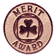

Bronze Merit: For dedicated service to Guiding

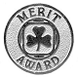

Silver Merit: For excellent service to Guiding

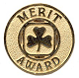

Gold Merit: For outstanding service to Guiding

An adult Member may receive any or all of the Merit Awards during her tenure in Guiding.
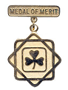
MEDAL OF MERIT:

This award is presented for exceptional service to Guiding, beyond the basic requirements for the position held and it is granted by the Province.

TEAM AWARD:
The Team Award may be given to each Member who has been part of a team that planned and carried to completion an extraordinary event or project. The award is primarily intended as an adult award, but there are times when girls are also part of the task group or committee. Therefore, as part of the team being recognized, girls will also be granted the award. The Team Award may be given more than once. This award is granted by the Council concerned.
Fortitude Award: 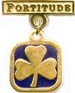
Presented by the Board of Directors to girl or adult Members who have shown great courage and endurance in adversity. The application comes from the Province to the Board and may be given posthumously in special circumstances. Consideration should be given to the Applicants contributions to Guiding during the time of adversity- was she still an active member, did she make significant contributions, etc? Applications for the Fortitude Award must be made as soon as possible preferably no more than one year (12 months) after the incident.
Valour Award: 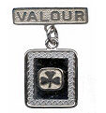
Presented by the Board of Directors to a girl or adult Member who has shown heroism in risking her life to save or attempting to save, the life of another person. The Valour Award is given in three levels, depending on the degree of risk:
Gold: For greatest heroism and risk to life.
Silver: For considerable risk to life.
Bronze: For high risk to personal safety.
Applications for the Valour Award must be made as soon as possible and no more than one year (12 months) after the incident.
Beaver: 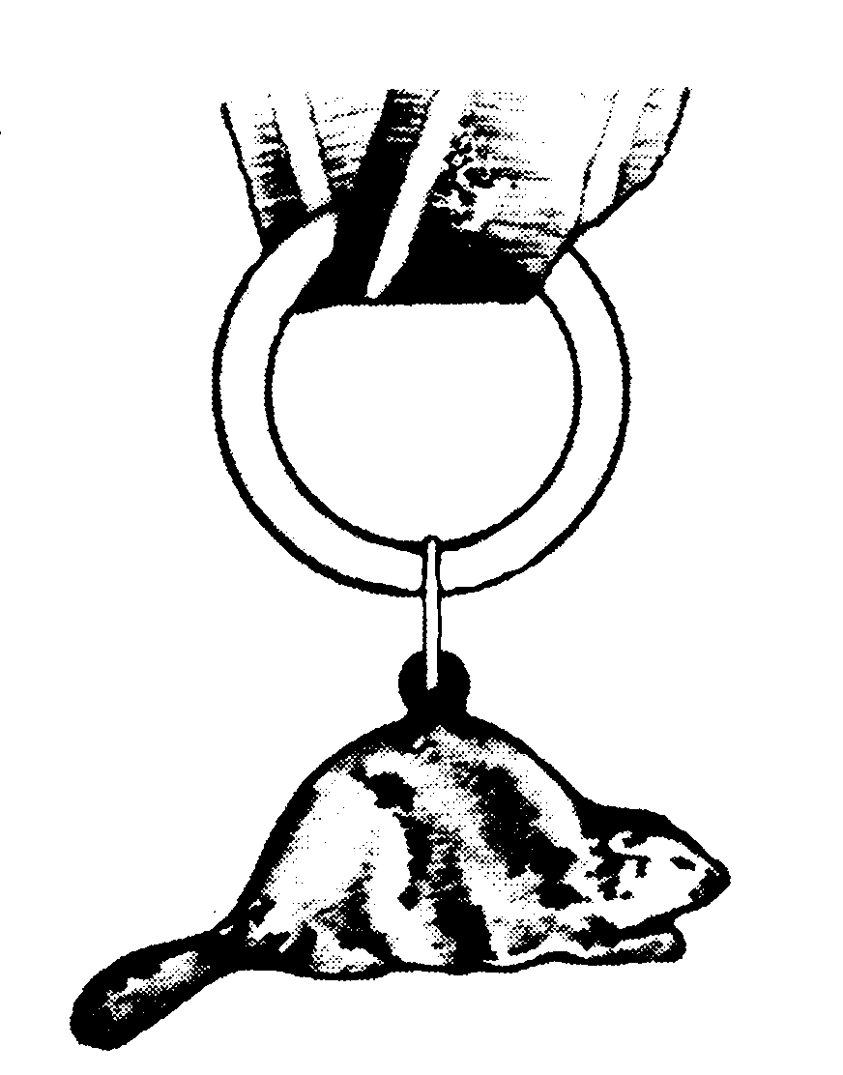
The Beaver Award is granted by the Board of Directors to adult Members for exceptional service to Guiding at the provincial or national Level. Except in special cases, it is awarded only to those who hold the Medal of Merit.
Gold Maple Leaf: 
The Gold Maple Leaf award is granted by the Board of Directors to adult Members for exceptional service at the national Level, which contributes to the enrichment of Guiding in Canada. It is only awarded to those who hold the Beaver.
Honorary Life Membership: 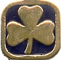
Honorary Life Membership is granted by the Board of Directors to adult Members still actively involved in the organization or upon retirement. Applications must be approved by the Commissioner concerned and accompanied by the required fee. Contact the provincial Commissioner for further details.

Awards Approved only by Nova Scotia Provincial Council:

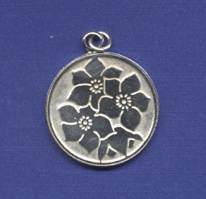
THE MAYFLOWER (Provincial Award)
The Mayflower is a very special Provincial award, which may be presented to someone who is making an outstanding contribution to Guiding within the Province of Nova Scotia.
- It is to be considered higher than the Medal of Merit, which serves as a prerequisite for the Mayflower Award. With approval of the Executive Committee, the Mayflower Award may be presented to a member who does not hold the Medal of Merit.
- The Guider's service may be to adults or to girls.
- Her service need not include a Provincial position or be known Province wide.
- Her service must be ongoing - not just for a one time task; she must still be
serving and intend to continue serving Guiding.
- Her service to whatever position she is holding must be above and beyond the
requirements of the position.
- Approval of this award cannot be based solely on past service that has been
previously recognized by presentation of another award. Additional service since the last award presented must be documented in the supporting letters.
Applications for this award must be accompanied by at least three letters of
documentation and support.
- Each application must be considered carefully on its own merits by the Provincial Awards Committee
- Final approval is given by the Provincial Executive (or Council).
- Applications must be sent to the Provincial Executive Committee AT LEAST THREE MONTHS before the intended date of presentation.

AWARDS REQUIRING AREA COUNCIL APPROVAL

AREA AWARD:

Each Area has the opportunity of creating, approving and presenting an award to their members. The Area determines the purpose, criteria, and design of this Award. Area Awards approved by Provincial Council for use in Nova Scotia are included at the back of this publication. Area Councils should send the criteria of the Area Award and the design of a PIN, if applicable, to Provincial Council for approval.
- Approval to create an Area Award is given by Nova Scotia Council.

APPROVAL OF AWARDS FOR TREFOIL GUILD MEMBERSHIP

All awards for members of a Nova Scotia Trefoil Guild, who are adult members and registered with Girl Guides of Canada - Guide du Canada, require Provincial approval. Because the Guilds in Nova Scotia are registered with Province, the Nova Scotia Council is considered to be the “Awarding Council” for the purposes of awards to Trefoil Guild members. The awards, however, will be purchased by the particular Guild that is recommending the award for their member.
The Trefoil Guild completes the R.3 Form and the Guild President /designate signs the form on the “Recommended By:” line and sends it to the Provincial Executive Committee for approval.

AWARDS FOR SUPPORTERS (Outside) OF GUIDING:
Often a unit, District or Area will have special people from the community, male or female, who give service to Guiding. This service may be on going or may be for a special event. Saying thank you for such support can be done in several ways:
- Certificates of Appreciation
- Gifts from the Guide Shop
- Gift certificates for a restaurant
- Thank you notes
- Girl Guide Cookies
- Silver Thanks Pin or Letter of Commendation
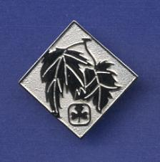
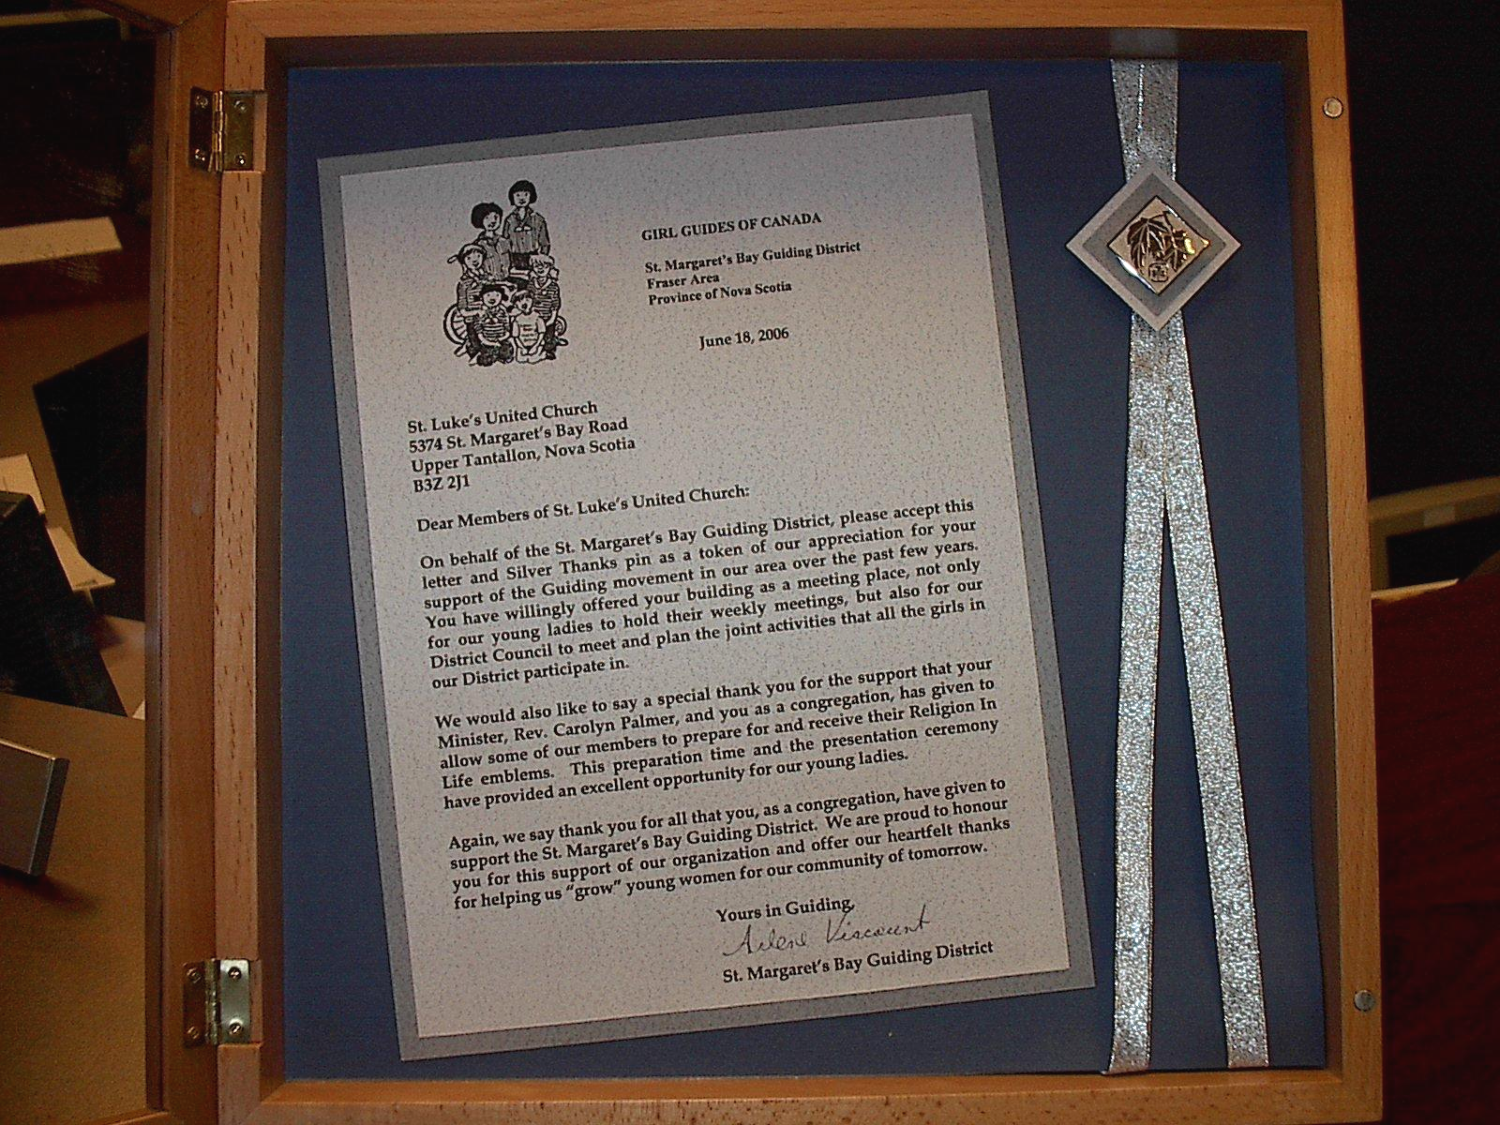
Silver Thanks Pin:

The Silver Thanks Pin may be given with the permission of the Commissioner concerned as a token of thanks and appreciation to non members and volunteers. It may be mounted and framed for presentation – see above.
Letter of Commendation:

A Letter of Commendation may also be presented to non-members.

Thanking our Volunteers:

Everyone likes to be appreciated! A kind word, a smile and a thank you goes a long way towards making a volunteer feel that her effort has been recognized. If a volunteer feels that her contribution to the organization is worthwhile she is more likely to talk to her friends into coming along for the fun & friendship! She is more likely to speak highly of Guiding to all she meets.

APPROVED NOVA SCOTIA AREA AWARDS as of April 2007

Colchester | Cumberland
Dartmouth lakes | Fraser
Fundy View | Halifax
Marine Shore

CHIEF COMMISSIONERS BURSARY:
The Chief Commissioners Bursary exists to support members of Nova Scotia Guiding in their studies beyond high school. Girls and women, who are current members of Girl Guides of Canada, Nova Scotia and who plan to continue their education beyond high school may apply, however if you have received the bursary twice you are not eligible to apply.
A Minimum Bursary of $500.00 is awarded annually, and is paid in September of the entrance year.
Application information, forms and deadlines are available from the Provincial Office or the Form Section of www.girlguides.ns.ca

REFERENCES

Guiding Essentials:
- Guiding Essentials – Section 5, Page 5.1
Girl Guides of Canada-Guides du Canada website: www.girlguides.ca
- Memberzone: Forms- Awards – R3

Canadian/Provincial Awards

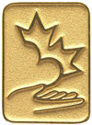 Caring Canadian Award – Volunteer Award
www.gg.ca/honours/awards/cca/index_e.asp
The Award consists of a certificate and a lapel pin, which are presented to the recipients by the Governor General while travelling in Canada or by a delegate, such as a Lieutenant-Governor or a Territorial Commissioner; the maple leaf, supported by a helping hand and heart, symbolizes the people of Canada and their spirit; the heart depicts the open-heartedness of volunteers and caregivers; the hand is outstretched to represent boundless generosity.

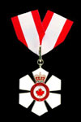 Order of Canada
http://canadaonline.about.com/cs/gg/a/orderofcanada
The Order of Canada is the centerpiece of Canada’s Honour System and recognizes a lifetime of outstanding achievement, dedication to the community and service to the nation. The Order recognizes people in all sectors of Canadian society. Their contributions are varied, yet they have all enriched the lives of others and made a difference to this country. The Order of Canada’s motto is DESIDERANTES MELIOREM PATRIAM (They desire a better country).

NOVA SCOTIA
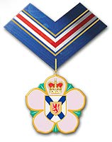 Order of Nova Scotia
www.gov.ns.ca/prot/order.htm
Any Canadian citizen who is a present or former long-term resident of Nova Scotia is eligible for nomination to the Order. The only exceptions are public officials (such as members of the Senate, MPs, MLAs, municipal councilors, or judges), who may not be nominated while they are in office. The Order may be awarded posthumously, if the person is nominated within one year of their death. Only individuals may be nominated, not couples, groups, or organizations.

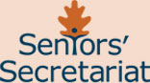

The Lieutenant Governor’s Intergenerational Award

http://www.gov.ns.ca/scs/intergenerationalAward.asp
The Lieutenant Governor’s Intergenerational Award recognizes the community contributions of Nova Scotia volunteers and draws attention to the great work and service that youth and seniors are making intergenerationally.
The Awards will be presented as follows: one for an outstanding Intergenerational Program; and two for individuals - one in recognition of an older person dedicated to serving the younger generation, and another to recognize a younger person dedicated to serving the older generation.
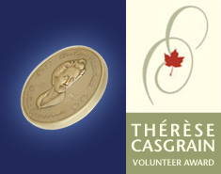

Thérèse Casgrain Volunteer Award

http://www.hrsdc.gc.ca/en/hip/sd/ThereseCasgrain/00_home.shtml
In 2001, the International Year of Volunteers, the Government of Canada launched the Thérèse Casgrain Volunteer Award. This award commemorates the work of Thérèse Casgrain and honours those who have demonstrated a lifelong commitment to volunteering.
The award is presented annually to two Canadians, one man and one woman. It recognizes volunteers from communities across Canada. Award recipients are individuals whose social commitment and persistent efforts have contributed significantly to the advancement of a social cause and the well-being of their fellow Canadians.
The award consists of a bronze medallion bearing the likeness of Thérèse Casgrain; a lapel pin; a certificate of recognition; and, $5,000 to be awarded to a registered Canadian charity designated by the recipient.
Deadline for nominations is February 1st.
Application for Recognition of Adult Service Awards-
The R3 How To’s!

