Aquatic Ambassador – Nova Scotia Crest Order Form
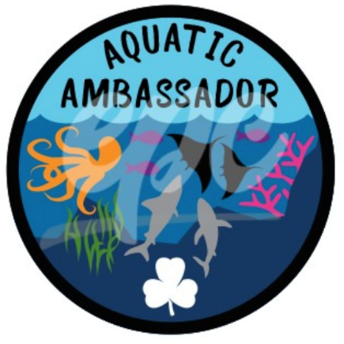
Congratulations! You are now an official Aquatic Ambassador.
To receive your crest(s), please send the completed form along with payment to:
Girl Guides of Canada – Nova Scotia Council
3581 Dutch Village Rd. Halifax, NS B3N 2S9

Email: ns-ggc@girlguides.ca
Payment Options:
- Cheques/Money Order made payable to Girl Guides of Canada.
- Cash/Debit at the Provincial Office.
- Visa/Mastercard- once order form has been sent, please contact the
provincial office 902-423-3735 to provide payment information.

Contact Guider:
Unit:
District / Area:
Phone #:
I will pick up the crests at the Provincial Office _____ or please mail:_______
Email Address:
Mailing Address:
Postal Code:

Crests:
 | @ $1.75 = | $
# of Crests: | Cost | Total Payment

We hope you enjoyed the challenge! Please share your challenge experience with us:

Questions please contact: ns-program@girlguides.ca

Social Media: @ggcnovascotia #AquaticAmbassador

