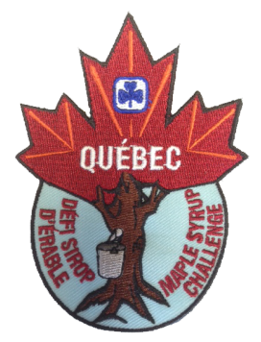
ORDER FORM
Québec Maple Syrup Challenge Crests

Maple syrup is a staple across the wonderful country that is Canada. Tap into one of our national icons, learning about its history, where it’s produced, what you can make with it and much more!

Crests are $2 each. Please complete this form and email it to: info@guidesquebec.ca

Date:

Guider name:

Guider email address:

Unit/District/Area:

Number of crests:

Please mail the crests to: (Let us know if the crests will be picked up at the office.)

Name: (if different from above)

Mailing Address:

Street:

City: Province:

Postal code:

PAYMENT

We will send you an invoice for the total amount including 5% GST, 9.975% QST and shipping costs.
Payment is accepted by cheque or credit card.

Cheques should be made out to: ‘GGC Québec Council’ and sent to: GGC QC Provincial office, 100 boul. Alexis-Nihon, Suite 270, Saint-Laurent, QC, H4M 2N7

If you would like to pay by credit card, please fill out the details below or phone us at 514-933-5839

Payment by Credit Card: | Credit Card Number
Visa Mastercard | Name on card |  |  | Expiry Date | /

