2015

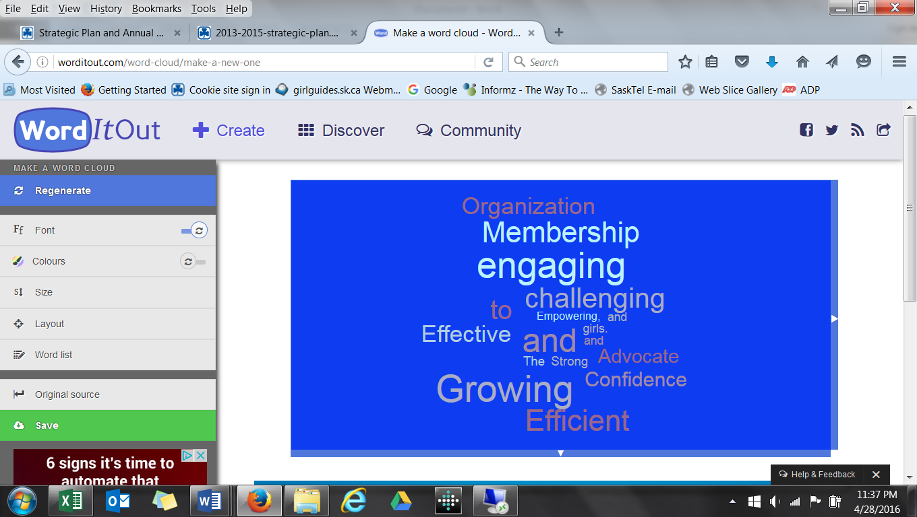



**Dear Members and Friends of Saskatchewan Guiding**

An annual report is an opportunity to reflect on the past year and offer a formal note of thanks to the individuals and community partners who have made 2015 a successful year. Please accept our resolution of thanks for your significant support for Girl Guides.

Girl Guides in Saskatchewan offers relevant and dynamic program and activities that enables our members to realize their full potential while having fun and developing friendships. The mission of Girl Guides of Canada-Guides du Canada is to enable girls to be confident, resourceful and courageous, and to make a difference in the world. Guiding in Saskatchewan continues to be a vibrant organization. We ensure that our members develop the skills to thrive and make a difference in their families, communities and in their world.

Our membership this year is 3366 (2,582 girl and youth members and 784 adult members). We offer programming in 54 communities with new communities requesting support to open as soon as possible. Girl Guides has proven to make a valuable contribution in a community.

The girl is at the heart of everything we do in Guiding. Leadership development is the goal and essence of our programming. We use a 'hands on' model that is developmental from Sparks to Rangers and into adult roles (ages 5-105). All members are encouraged to step into leadership roles. They are encouraged to 'learn by doing'. As they practice, they foster confidence, knowledge, skills, values and positive attitudes. Girl Guides prepares our members to be a leader in any situation. We encourage the members to have an active voice on issues that are important to them and possess the skills needed to effectively make a difference.

Adult volunteers are critical to our success. The adult volunteers share their skills, talents and often their resources with the girls. Weekly they mentor the girls. The adult leader creates a safe environment where the girls can have fun, develop skills, and explore the areas that interest them as they share in the event planning and delivery. Memories are created. The ability to see a need and lend a hand is one of the organizations core values. We extend our heartfelt gratitude to all our adult volunteers and your commitment to our organization. Girl Guides could not happen without you. For all you do for our girls – Thank You.

Girl Guides recognize the parent and the key role they play in our organization. Each parent makes a choice to register their child with our organization. Parents often step in and support projects or offer leadership in the unit. I trust you see the positive impact and opportunities we offer. Thank you for your support in the organization.

Cookies are the fuel for our organization. Our appreciation goes to all the extended families, friends and neighbours who support our cookie campaigns. We receive generous support from Saskatchewan Parks and Recreation and the Community Initiative Fund. Their funding enables us to offer provincial programming options. Thank you.

Finally, I want to personally thank you for your support of me as your Provincial Commissioner. My five year term has come to an end. What a privilege it has been to champion Guiding in Saskatchewan. The role has lead me into some wild adventures and crossed my path with many amazing women. There has been lots of work for sure but the journey has been a blast. I have done ‘my best’. I will miss the opportunity to connect with you. Thank you for the memories and friendships that I have gained in this role.

Your Sister in Guiding

Charlene McLean

Provincial Commissioner

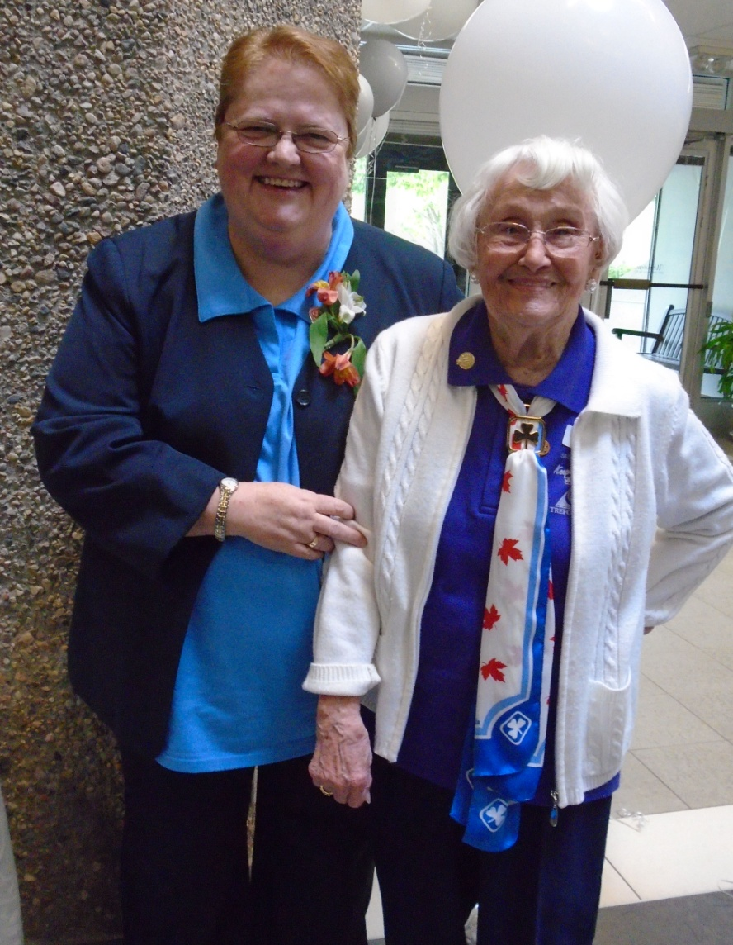

Saskatchewan Council Annual Report

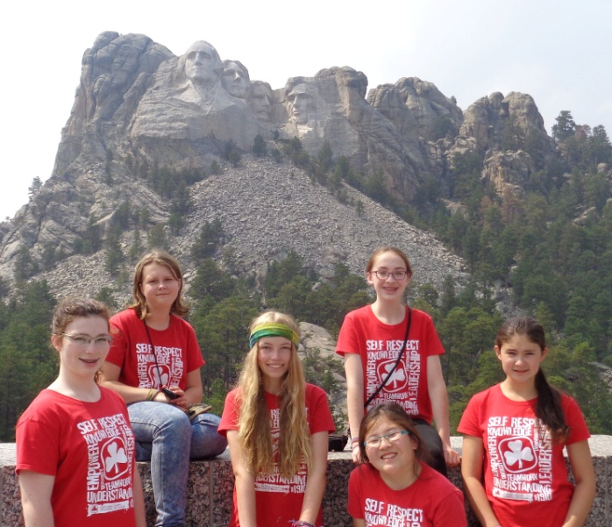

* Spring classic cookies 10,800 cases, Fall mint cookies 9,107 for an overall increase of 12% from last year
* Trainers provided over 500 hours of training
* We aligned membership assistance sources in to one application form
* Property upgrades to enhance energy efficiency
* Streamlined the grant funding application process

EFFICIENT AND EFFECTIVE ORGANIZATION

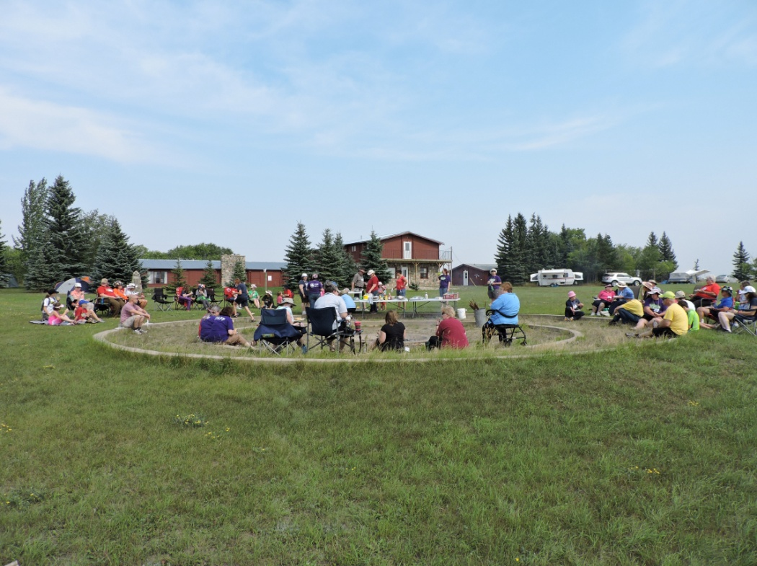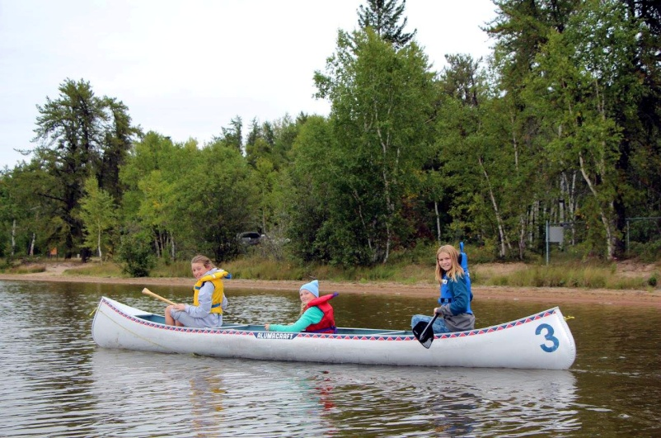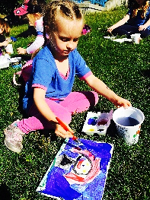

* 2582 girl members, 784 adult members for a total of 3366 members overall
* Membership decreased by 0.24%
* New Units in Melfort and Regina
* Increased the number of trainers allowing more training opportunities. 130 Guiders attended January Conference
* Increased our presence on Social Media (Facebook group 306 members)

STRONG AND GROWING MEMBERSHIP

**Saskatchewan Honourary Members**

|  |  |  |
| --- | --- | --- |
| Elaine Andreas  Margaret Asquith-Morrey  MaryAnn Assailly  Wendy Barker  June Bleier  Shirley Byrnes  Elaine Chatterson  Marian Clark  Elizabeth Collicott  Margaret Ferguson  Audrey Forrest  Sandra Hamilton | Judith Kehler  May Kletke  Muriel Kochanski  May Lumbis  Eveline Lundgren  Marjorie Martens  Charlene McLean  Patricia Melnychuk  Lois Morrison  Marie Morrow  Carolyn Oleniuk  Gladys Ollinger | Kathy Palmer  Phyllis Pearson  Rose Ruller  Carol Schimnosky  Carol Skaar  Joyce Spence  Pauline Stenzel  Jo Szostak  Janet Thompson  Bonny Tolley  Gina Troupe  Lorraine Vinterlik  Sheila Wilson |

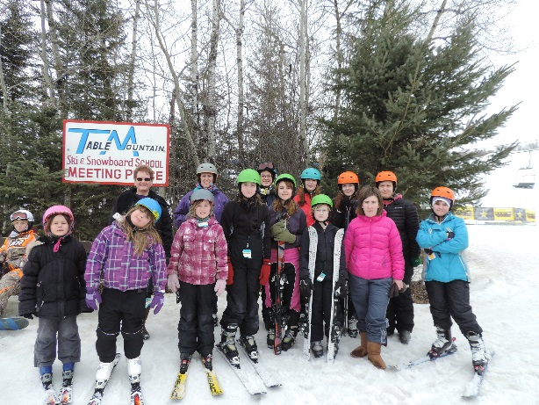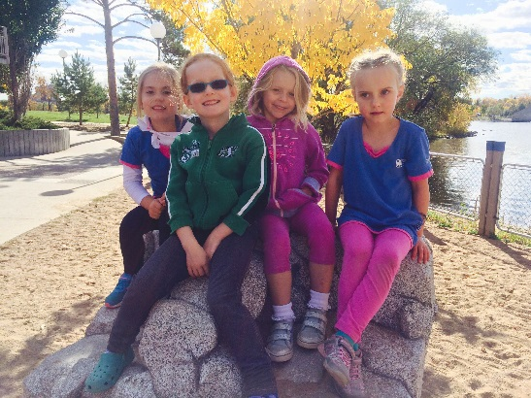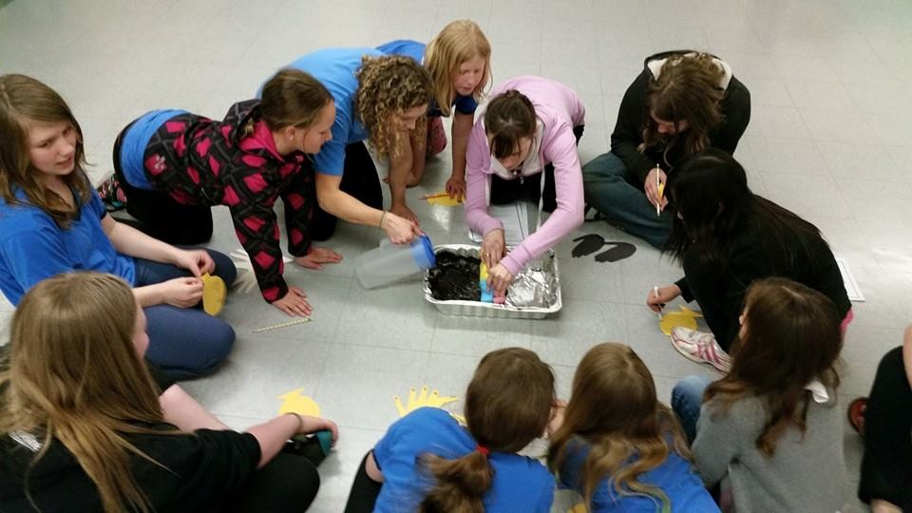

**Resolution of Thanks**

Thank you to the following in appreciation and recognition for support of Saskatchewan Girl Guides

|  |  |
| --- | --- |
| * Saskatchewan Girl Guide Members, Guiders, Girls, Parents and families * National Board & office staff and other Provincial offices * Urban and Rural Communities, local businesses and service groups * First Nations Bands * SPRA | * The Honourable Vaughn Solomon Schofield, Lieutenant Governor of Saskatchewan * Provincial and Area office staff * Saskatchewan Government * Saskatchewan Media * Tim Hortons * Safari Club International |

* Day of Pink – Anti Bullying
* Words in Action – Literacy Challenge
* 9th Annual Tim Horton’s Community Clean-up – 2000 participants
* Run for the Girls
* Partnered with Read Saskatoon, Frontier College, SK Environmental Society

CONFIDENCE TO ADVOCATE

* Day Camps/Sleepovers/ Camping.
* 511 girls and adults attended provincial camps at Can-ta-ka-ye & Heritage
* 472 nights of camping at Can-ta-ka-ye and Heritage
* Lady BP Weekend
* Pathfinder/Ranger Conference
* Spark Sprees/Brownie Revels/ Guide Rallies (1500 participants)
* Enhanced Arts involvement
* Community Service
* Environmental Awareness
* Adventure opportunities
* Public Speaking
* Project Planning
* Shared leadership opportunities
* Today’s Life Skills
* Innovative Program Work
* Badge work
* International Travel
* Interprovincial Travel
* Twinning Challenge – El Salvador
* Hike Around Saskatchewan (400 participants)

dynamic programming for girl greatness

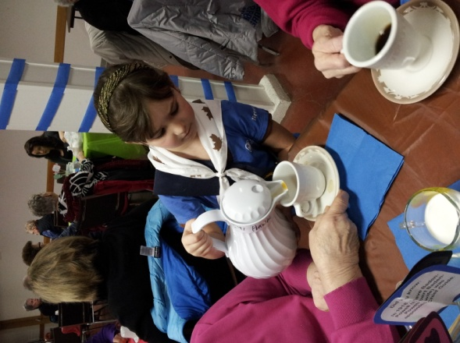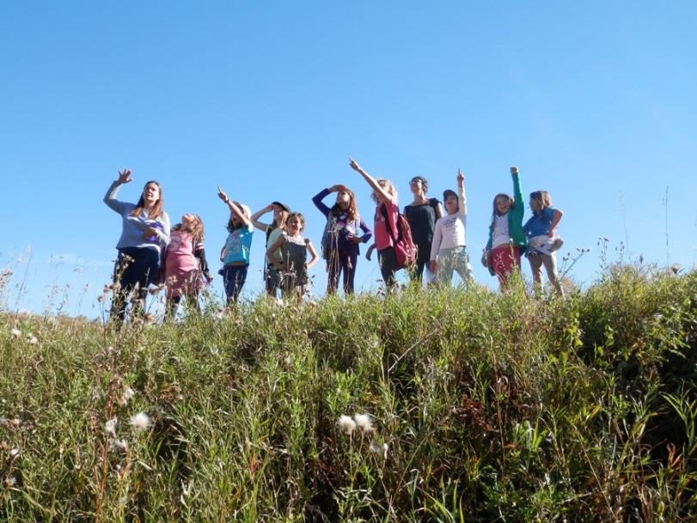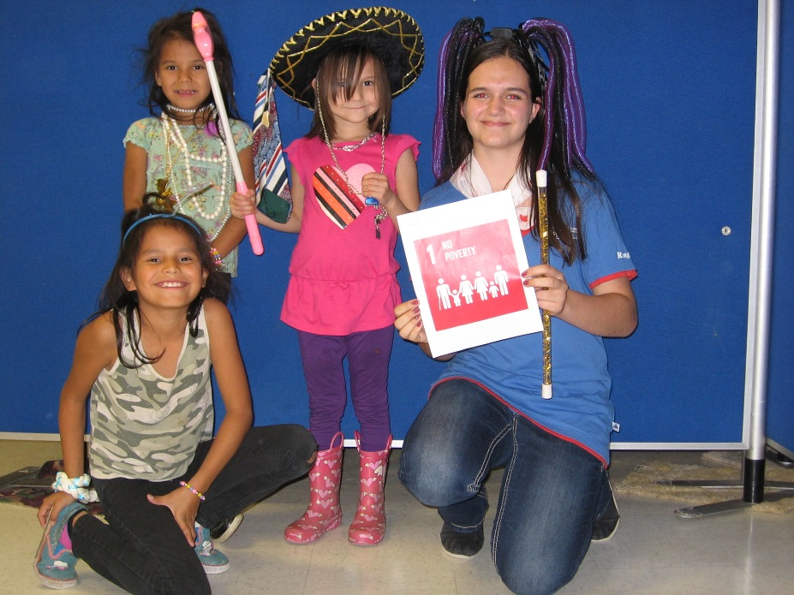

Donations and Grants

**Thank you to the following who have provided a financial contribution to Saskatchewan Girl Guides**

* **Saskatchewan Parks and Recreation Association for providing program and membership support**
* **Community Initiatives Fund for providing program and camp funding**
* **SaskTel Pioneers for providing support for Can-ta-ka-ye**
* **Saskatchewan Guiders who donated to Sisters to Sisters Fund**
* **Individual donations from the general public**

Camping – Barb Atkinson/Linette Plant

Safe Guide – Carol Skaar

Can-ta-ka-ye Operating Chair – Heather Neufeld

Heritage Operating Chair -

Susan Prakash

Communications – Amanda Lang

International – Ashley Geddes

Membership – Vacant

Awards – Megan Clake

Link – Erin Spinney

Trefoil Guild – Judi Kehler

Program – Sara Horseman

Lones – Lorraine Thibeault

Special Needs – Vacant

Public Relations – Alice Gaveronski

Archives – Audrey Forrest

Cookies – Megan Clake

Training – Carrie Morrison

Arts – Ali Peters

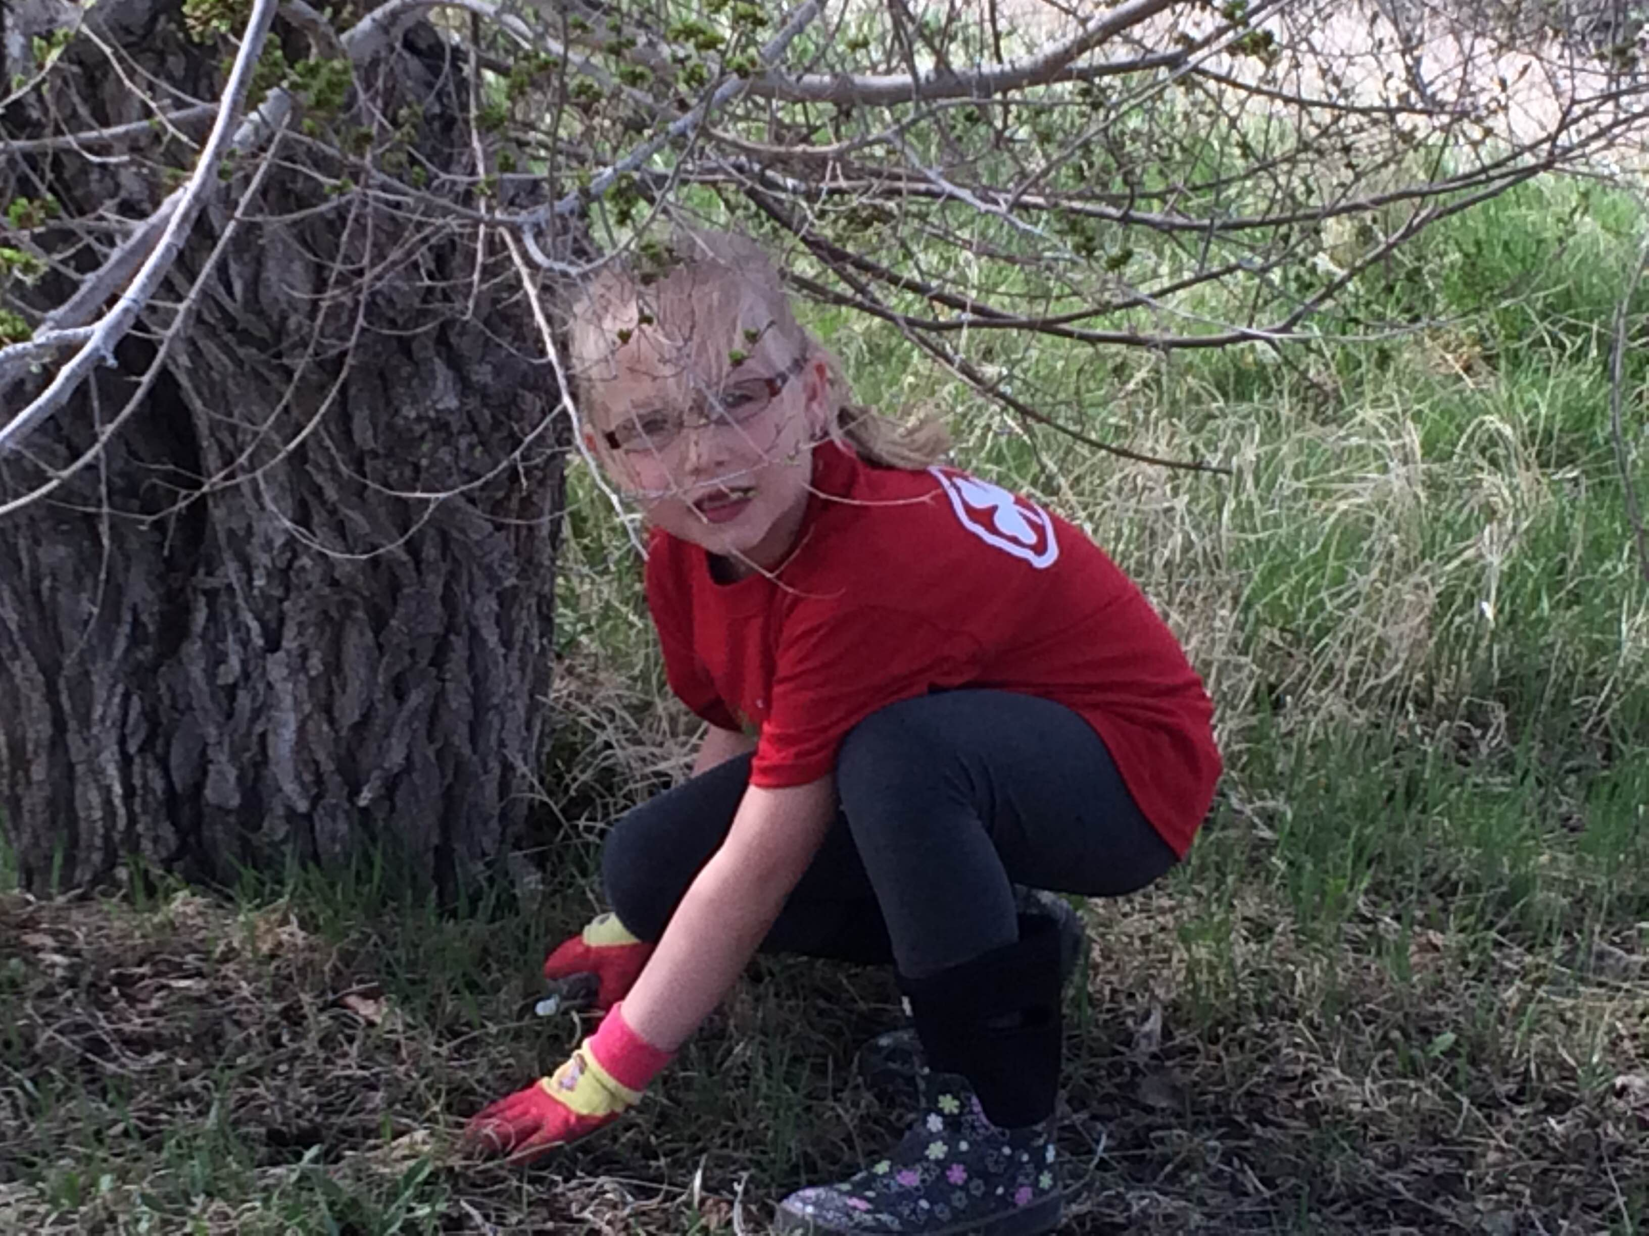

Finance – Glenda Eden

Fund Development – Phyllis White

Literacy Agents – Brenda Lee & Desire White

Twinning Co-Leads – Melissa Gartner & Danielle D'Entremont

Human Resources – Judi Kehler

Prairie Lily Editor – Marg Stewart

**Networks and AdHOC Committee Chairs**

Provincial Council

**Provincial Commissioner - Charlene McLean**

**Deputy Provincial Commissioner - Phyllis White**

**Provincial Treasurer - Glenda Eden**

**Bridging Rivers Area Commissioner - Laurie Lanovaz**

**Southern Horizons Area Commissioner- Michelle Gibney**

**Elected Members: Bonnie Jean Low, Laurie Toews, Janice Graessli, Kay Peters, Charlotte Courage, Alexa Wallace**