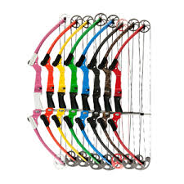
SK Council Archery Guidelines

NASP certification
- GGC have been accepted as an accredited youth program to offer the NASP archery program with certified NASP equipment as long as all of GGC archery instructors are following NASP policies and procedures and maintaining the NASP BA1 certification.
- Members need to register their cortication credentials with Area/Provincial office and the certification is recorded on IMIS.

Protocol
- Non-members who have been recruited to provide the archery event must submit their credentials for verification prior to the equipment being released.

- Small rental fee for lost or broken arrows to be used towards replacement and maintenance
- A user fee of .50/participant (small fee to be used to replace and repair equipment)

- Damage deposit (refundable) Recommendation: $100 fee be charged and returned if all equipment is returned on time. If equipment is lost, broken or not returned on time the damage deposit or a portion of it is not returned to the renter.

- Rental is on a first come first served bases. Safe Guide approval notice for any activity that includes archery must be sent to Area office prior to releasing the equipment.

- Transportation or shipping cost is the responsibility of the renter

Storage
- Regulated by each area office. Office staff and Range Master should ensure all equipment is in good repair prior to leaving and upon return.

