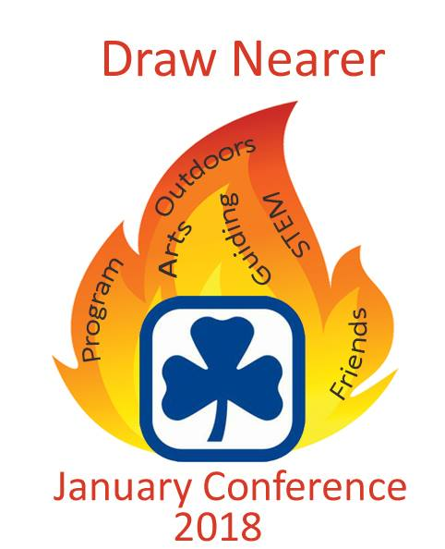
January Conference Registration Form
January 19 – January 21, 2018 Regina Travelodge
ALL RANGERS WELCOME TO DRAW NEARER!
Name: _____________________________________ iMIS #: __________________

Phone (home): _______________ (work): ______________ (cell): _______________

_____________YES, I AM A RANGER
I prefer to receive information by:

Email: ______________________________

Fax: ________________________________

Mail (address): ___________________________
City/Town: _____________________________
Postal Code: ____________________________
Food/ Allergies/Diet and/or physical restrictions: _________________________________________________

I would like to share a room with (if applicable): __________________________________________________

Smoker Non-smoker Note: All rooms are non-smoking rooms! Please make this a Scent free event!
Optional: For grant purposes please self-identify if you are: € First Nations € Metis € Inuit or € an immigrant.

Register early and save $25!
For Safe Guide purposes, RANGERS are to ROOM WITH RANGERS, not Guiders or moms. Thanks!  Prices are per adult or Ranger (GST included) | Early Bird  before November 30 | Regular Price  after November 30
Conference & hotel – 1/room | $370 | $395
Conference & hotel – 2/room | $220 | $245
Conference & hotel – 3 or 4/room (sharing beds) | $200 | $225
Conference only – no hotel | $130 | $155

After December 15, registrants will pay the “Conference only” fee and be responsible for arranging their own accommodation. The hotel will not guarantee the room rates or availability after that date! Please check with the Provincial Office first as we may have a few spots to fill within the rooms we have booked.
- No registrations can be accepted after January 11, 2018.
- Price includes: Saturday and Sunday breakfasts, Saturday lunch, Saturday banquet, coffee break drinks and evening hospitality.
- The Session Choices and Session Choices Form will be available via the HOMEPAGE/UPCOMING EVENTS SECTION of the PROVINCIAL WEBSITE - http://www.girlguides.ca/web/SK/Home/SK/Default.aspx?hkey=d8f60f59-d894-4748-a76a-bfdcf3644622
Please return a complete Registration Form with payment to the Provincial Office.
Conference Logistics:
- Registration Friday evening 6 – 7:15 p.m. Sessions start Friday evening at 7:15 p.m.
- Saturday Breakfast 7:30 – 8:30 a.m. Morning Sessions 8:30-10:15 and 10:45 – Noon
- Saturday Lunch 12:00 – 1:30 p.m. Afternoon Sessions 1:45–3:00 and 3:45 – 5 p.m.
- Saturday Reception 6 p.m. Banquet and evening activity start – 6:30 p.m.
- Sunday Breakfast 7:30 – 8:30 a.m. Morning Session – 9:00-11:45 a.m.
Payment enclosed: ____________ (Cheque payable to Girl Guides of Canada, SK Council)
OR Credit Card # _______________________________________ (VISA, MC only) Expiry Date: ___________________

Girl Guides of Canada, SK Council
REFUNDS: This fee is refunded less $25 administration fee until two weeks prior to the event. Within those two weeks, a written request must be sent to the Provincial Office for consideration of any refund.

200-1530 Broadway Ave., Regina, SK S4P 1E2
OR Email provincial@girlguides.sk.ca
OR Call 306-757-4102 or Toll free 1-800-565-8111
OR Fax 306-347-0995

